**IAM (Identity and access management )**

* Log in into AWS console
* Go to IAM

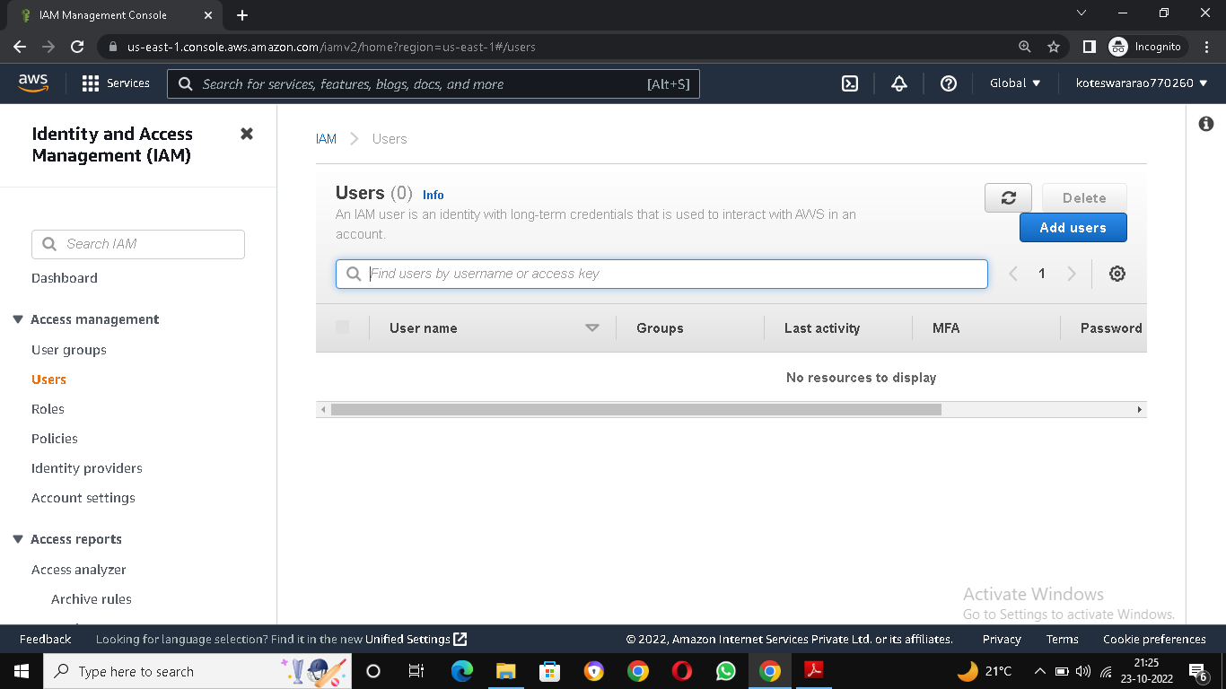

* Click on add user for creating a user
* Give name and add access permission “AmazonEC2full access”

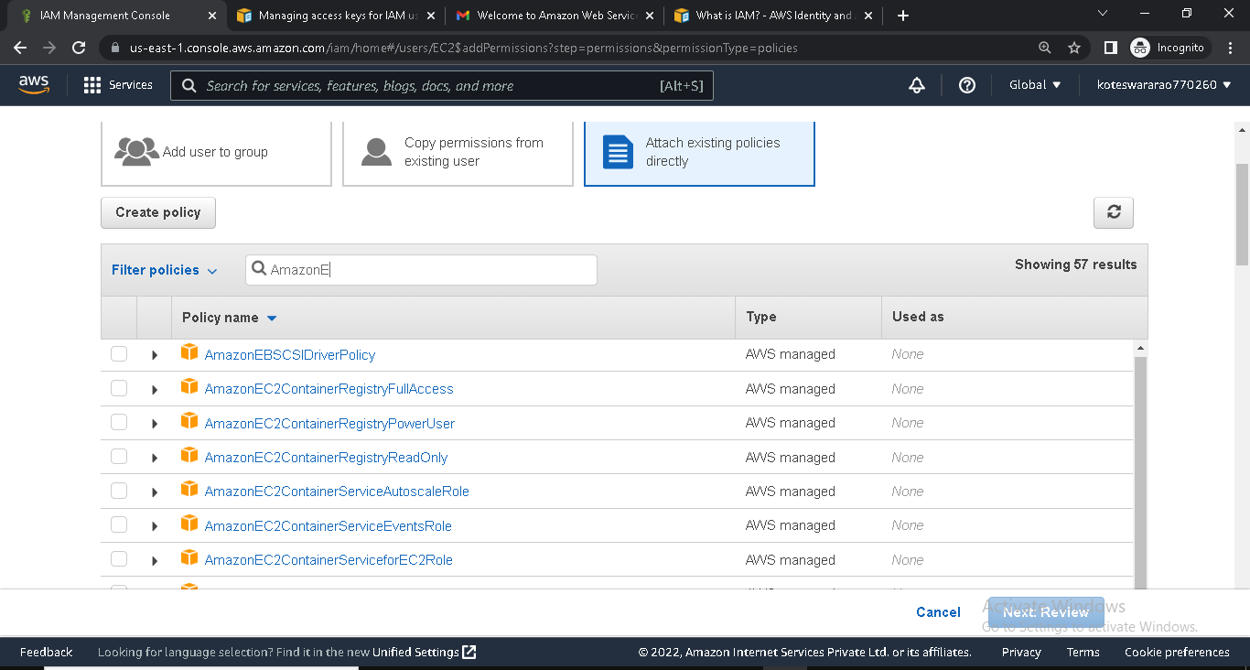

* Add password for security for the user
* Created the user and it will send email option for give the access for user
* Go to mail click on the link and type user id and password
* Check we gave access work or not

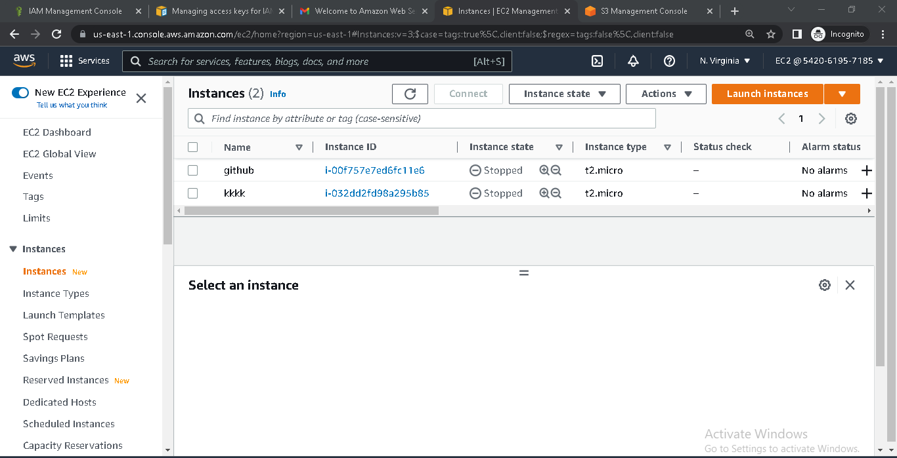

* Check other service for example S3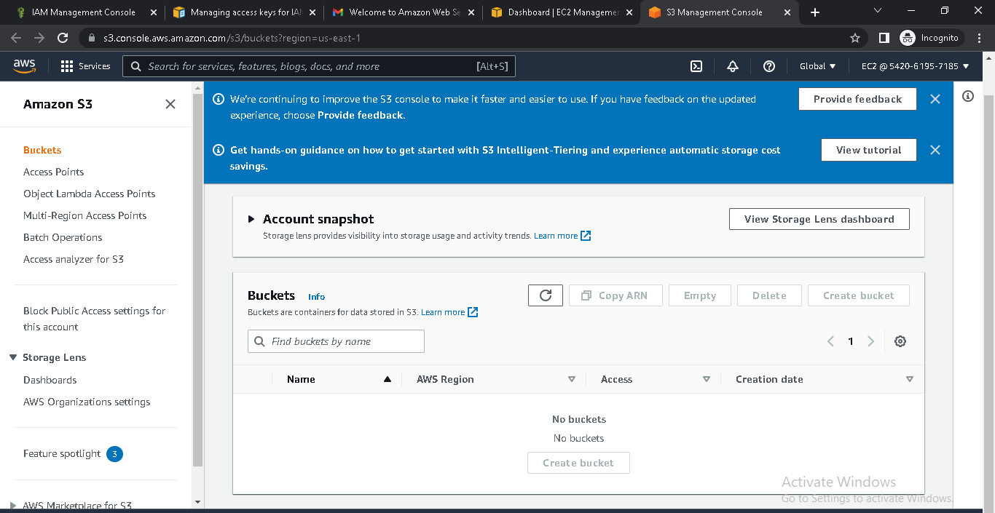
* Add another permission as administrator access

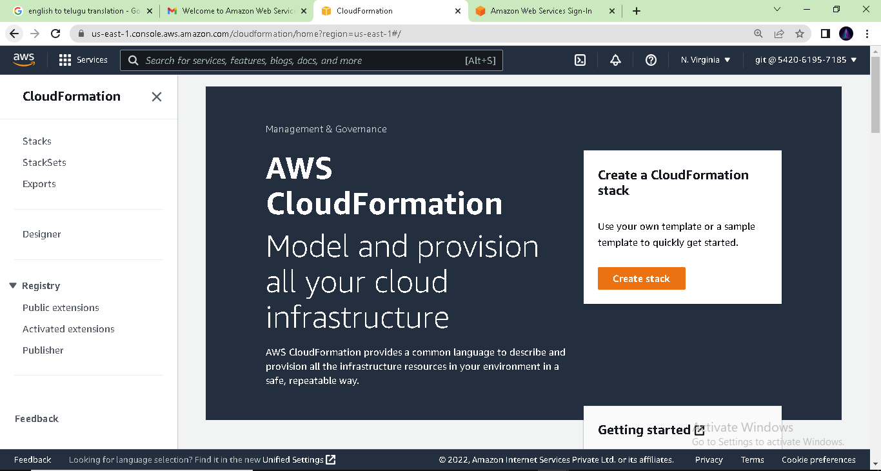

BILLING ALARM

* Log in into AWS console
* Go to cloud watch

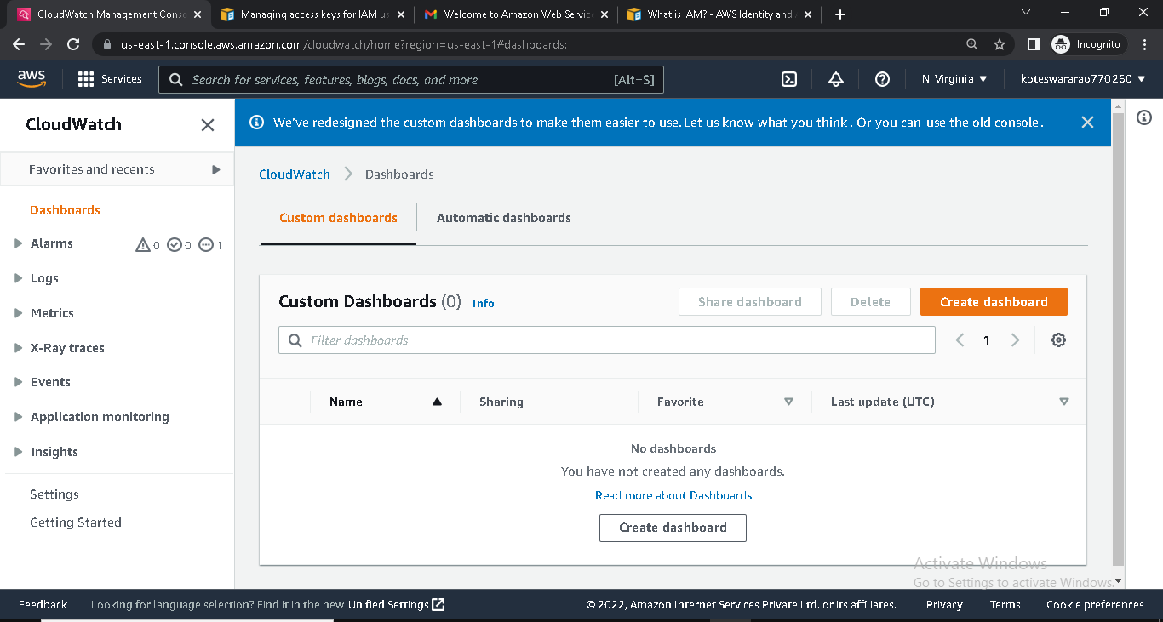

* On the left we will find alarms
* Click on the alarms
* Choose the billing

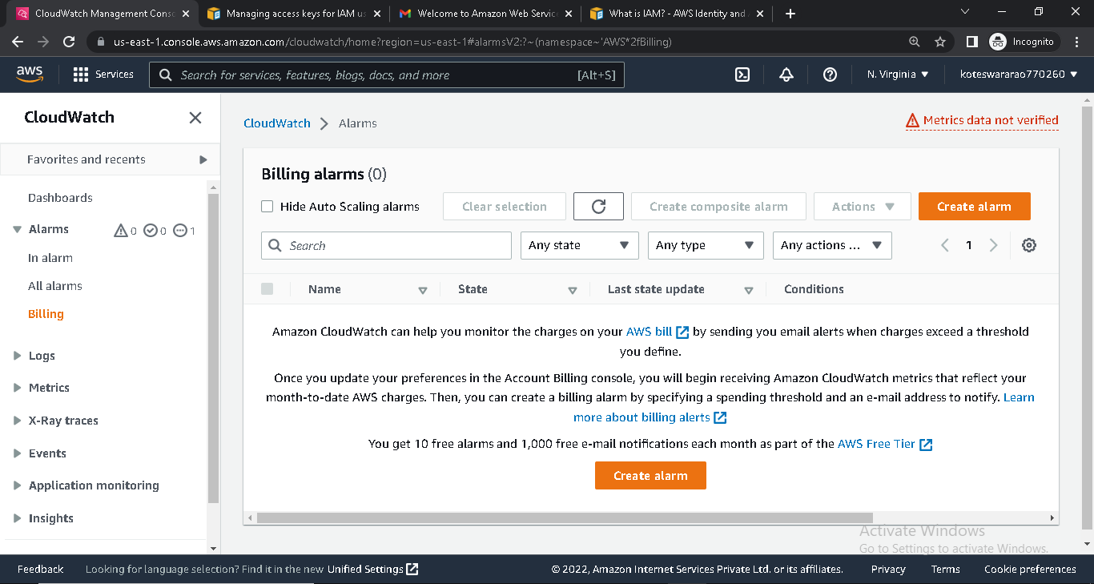

* Click on create alarm
* First stage is specify the metric and conditions
* Select metric

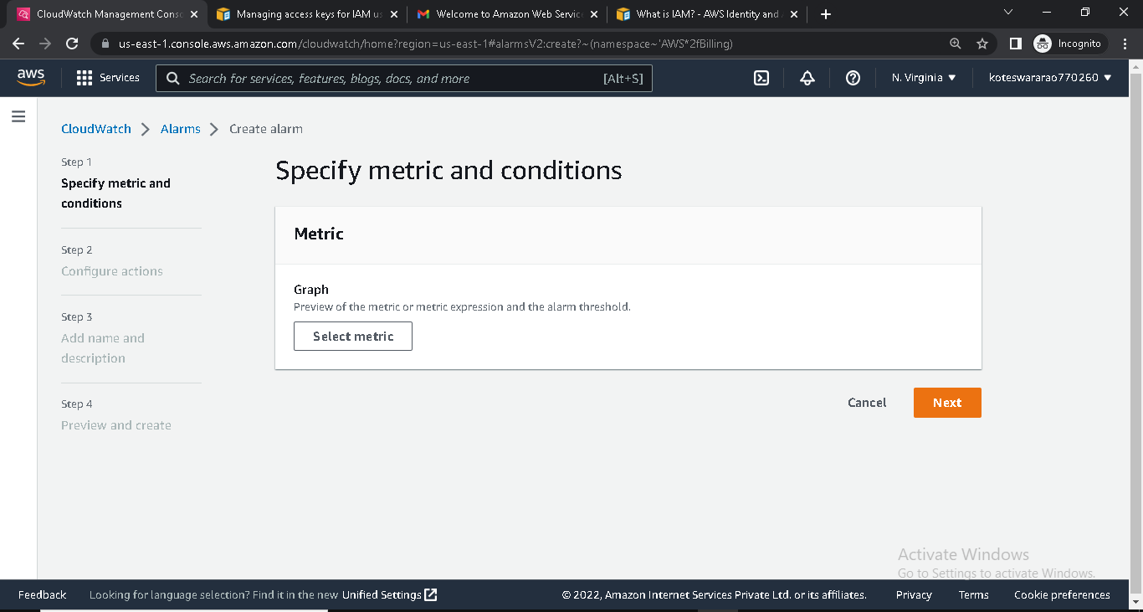

* Select EC2 and pre instance metric (select any instance)
* Give conditions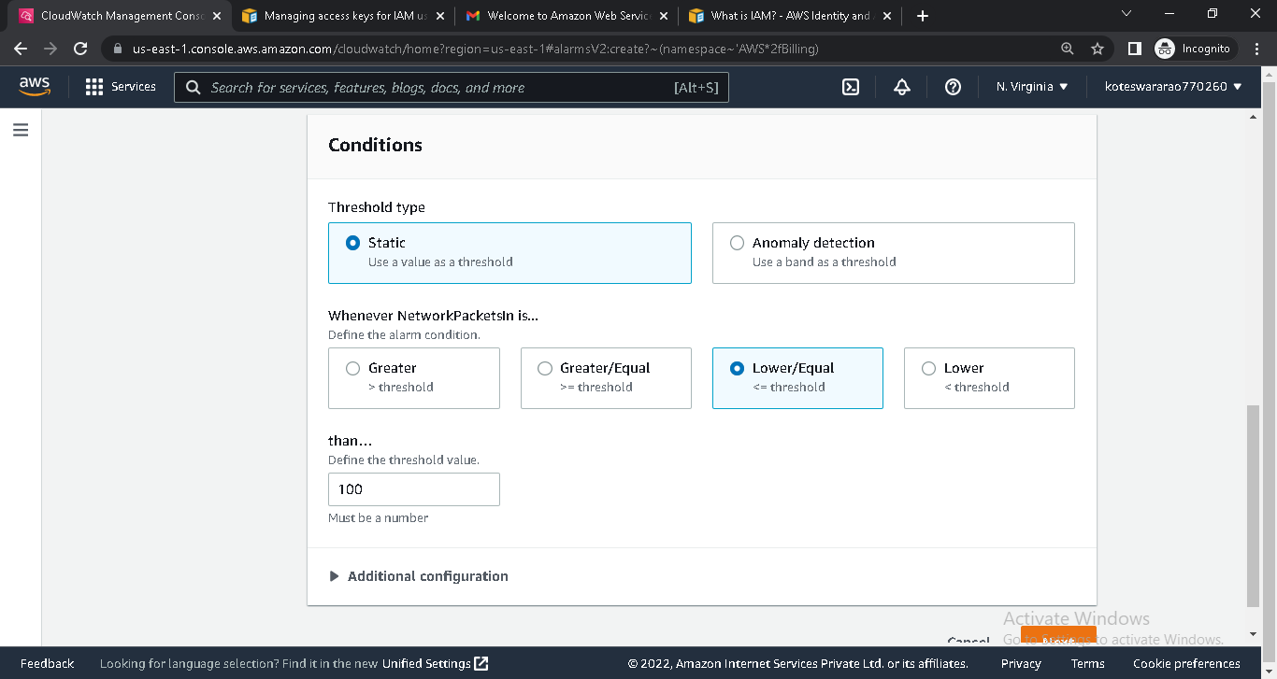
* Give notifications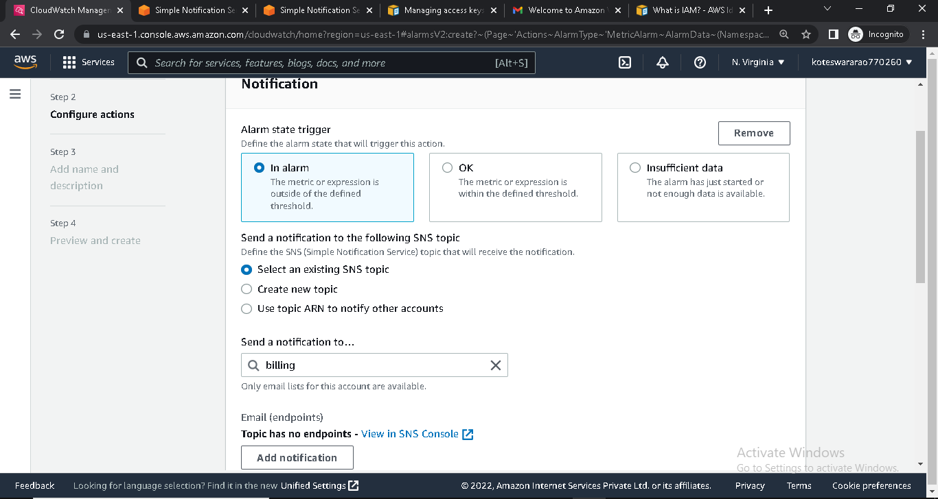
* Add name and description
* Created alarm for billing

**Create a S3 Bucket**

* Log in into AWS console
* Go to S3

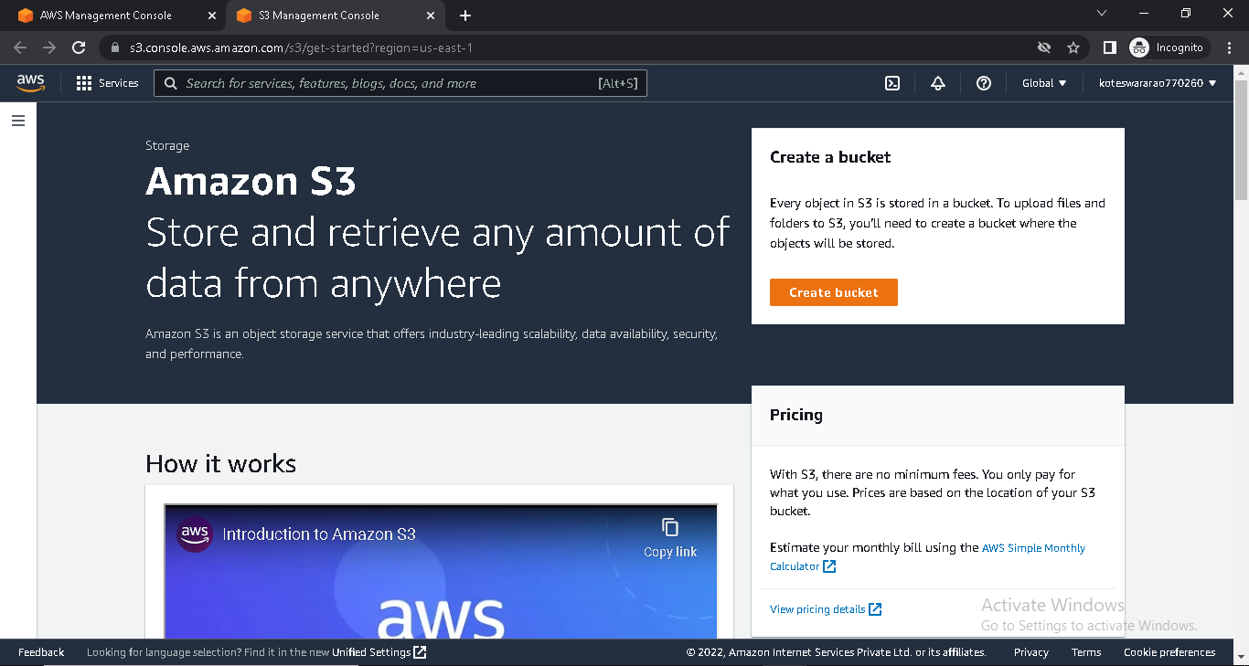

* Create bucket

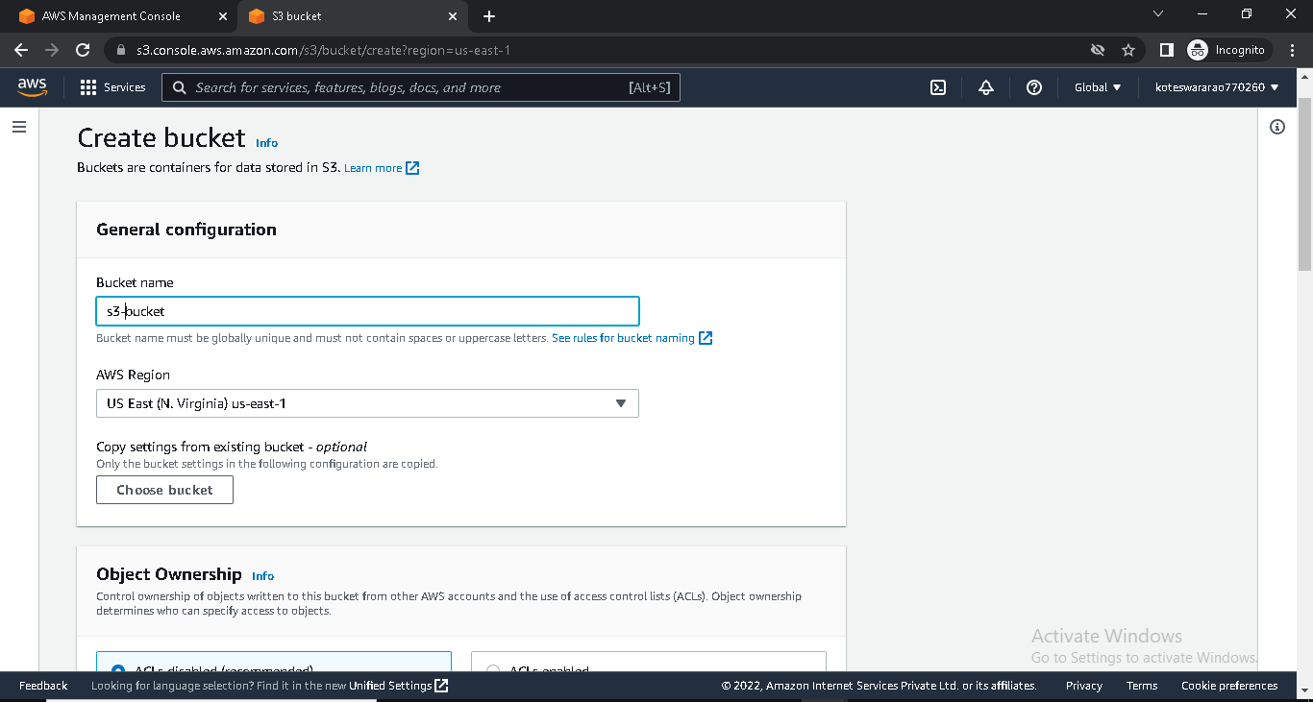

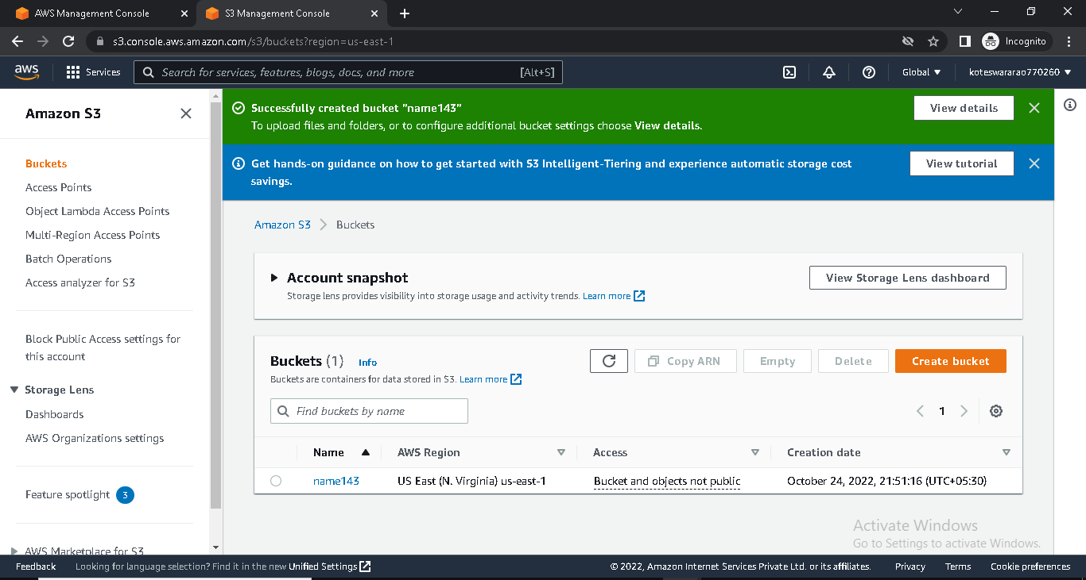

* Click on S3 bucket

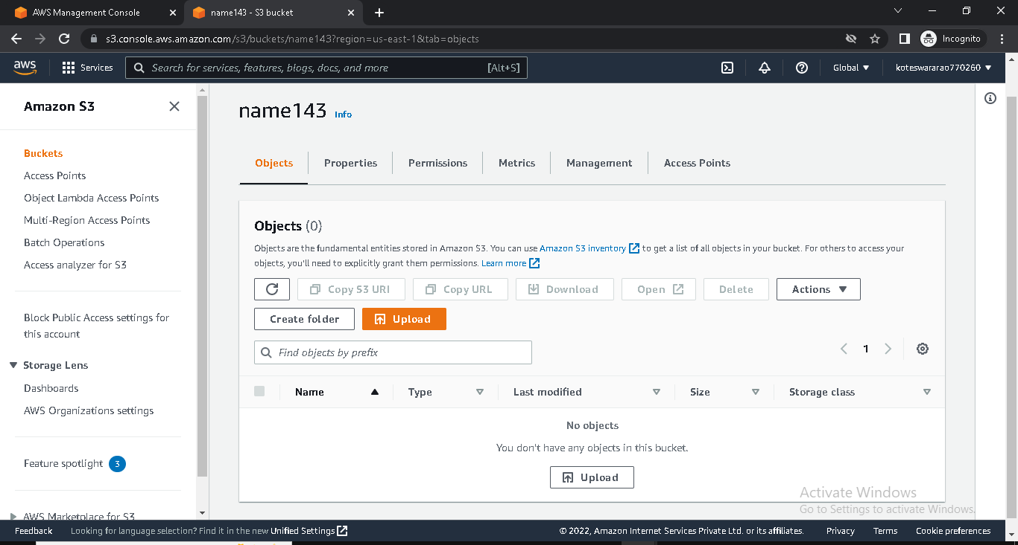

* Click on upload
* Click on add file
* Add the file

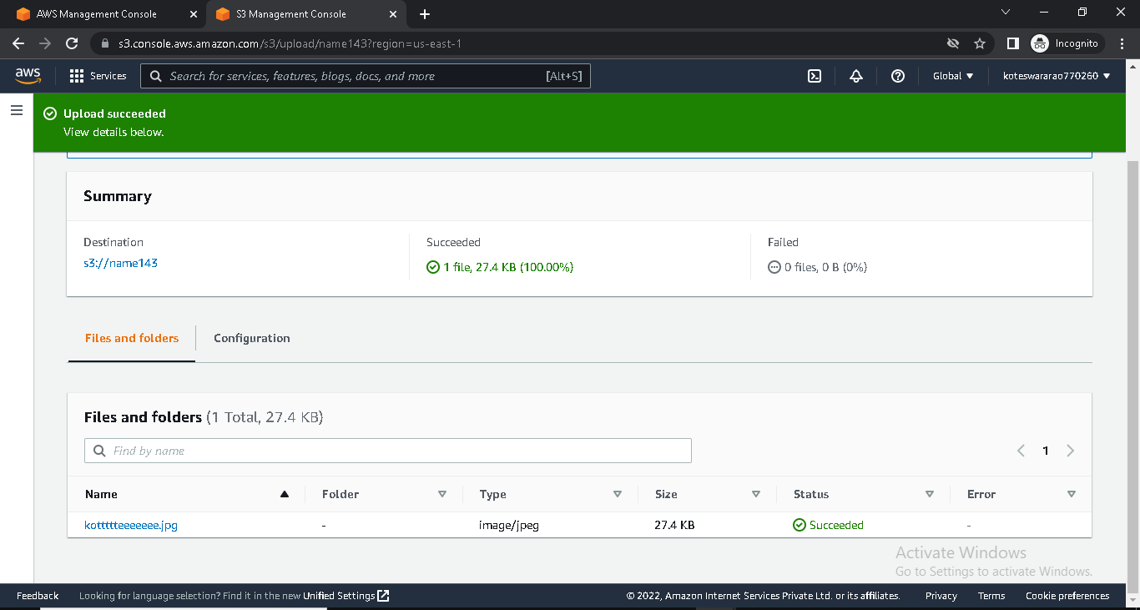

* Click on the uploaded file

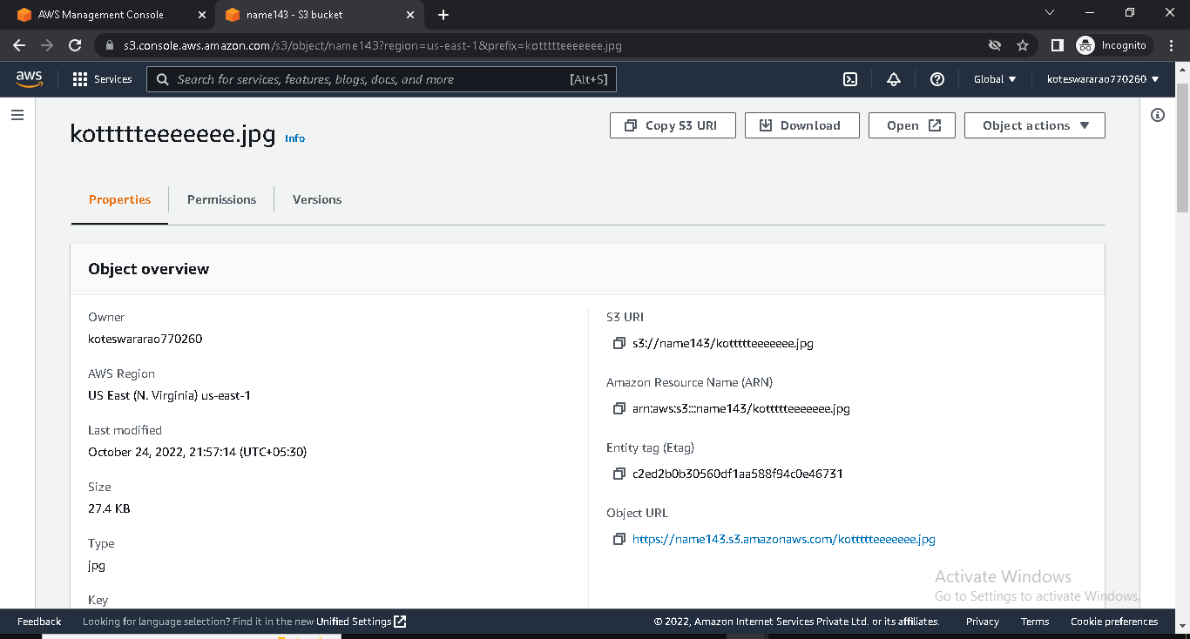

* Copy URL of S3
* Paste it in google tab
* Than, we will get error

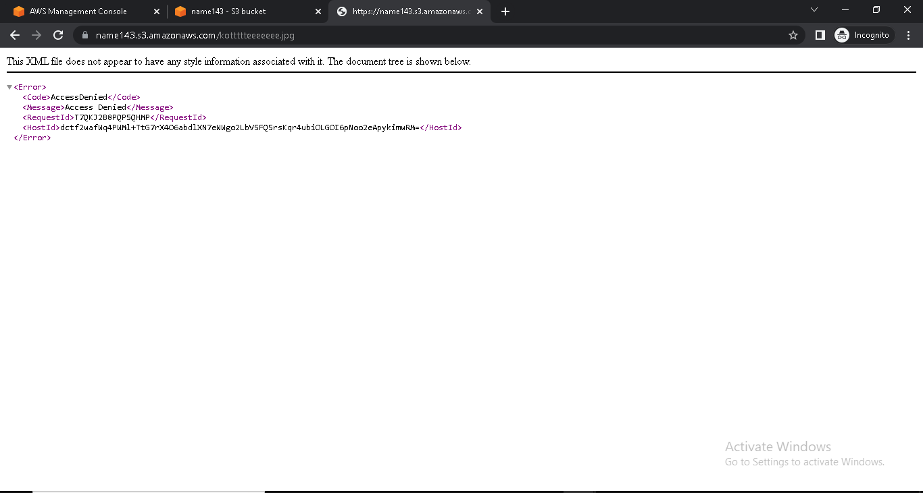

* Click on bucket name
* Go to permissions
* Turn off the block public access

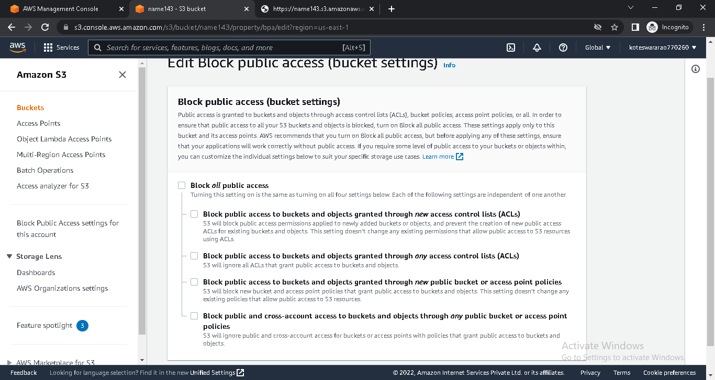

* Click on Object ownership and enable it

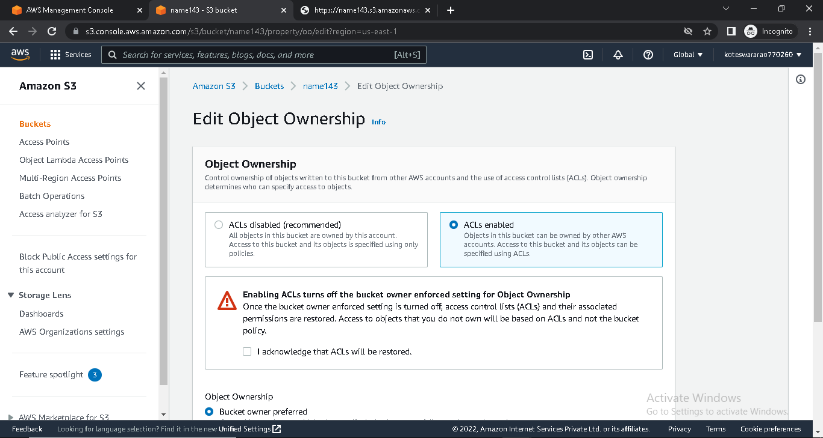

* Select the uploaded file
* Go to actions
* Make the public using ACL

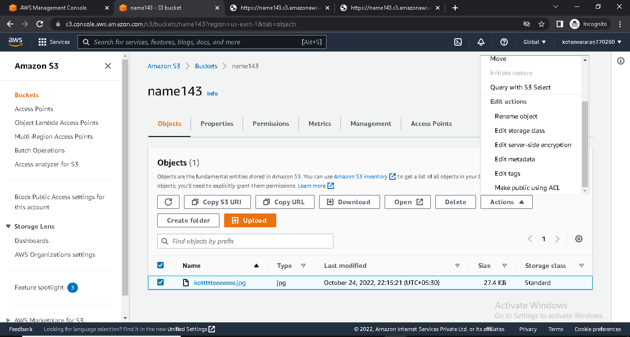

* Copy URL of uploaded file
* Paste it in google tab

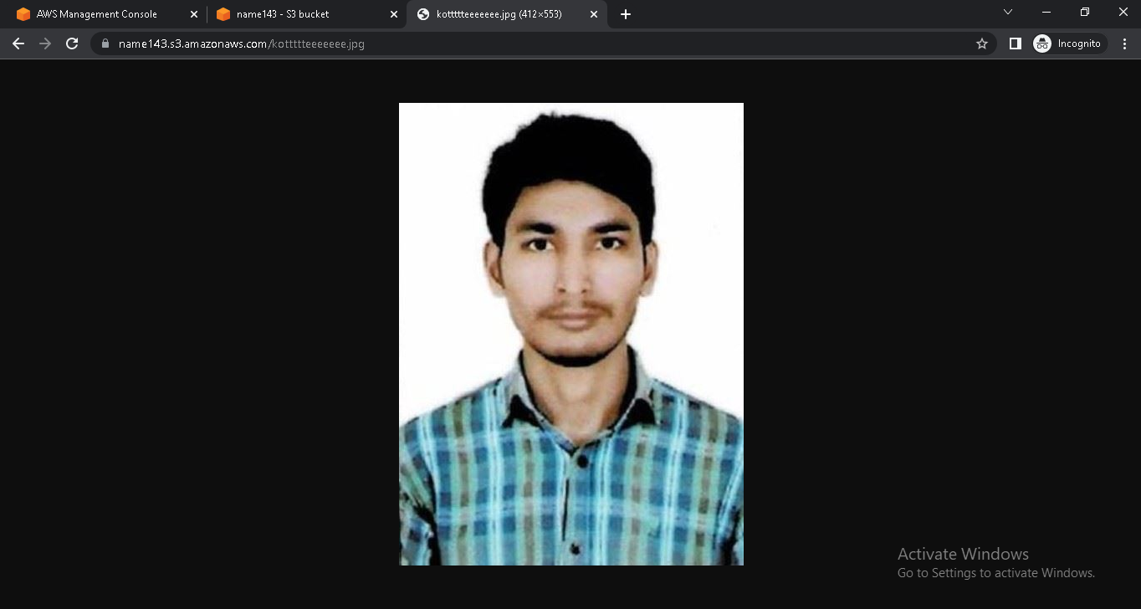

* Edit the bucket versioning enable it

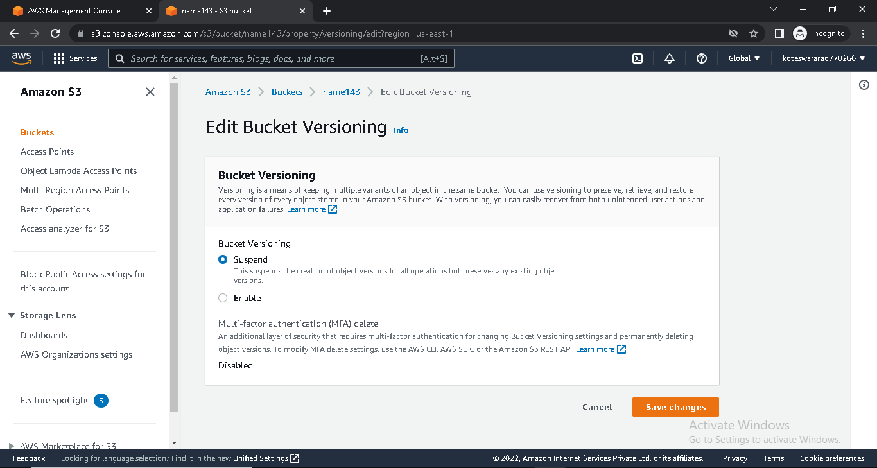

* Upload a file
* Make it public
* Copy URL of uploaded file
* Paste it in google tab

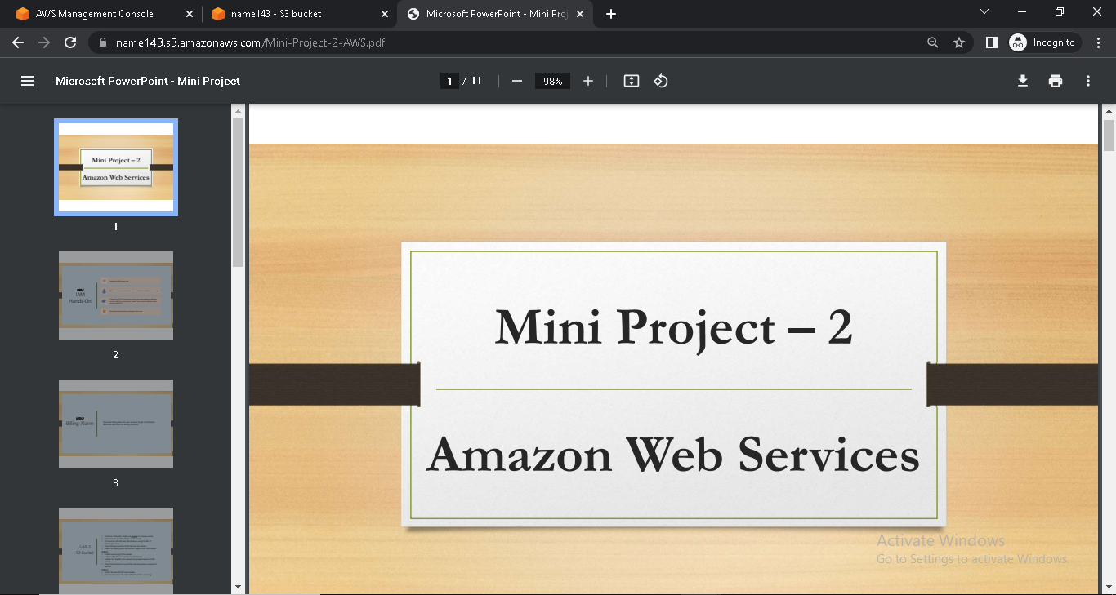

* Delete text file

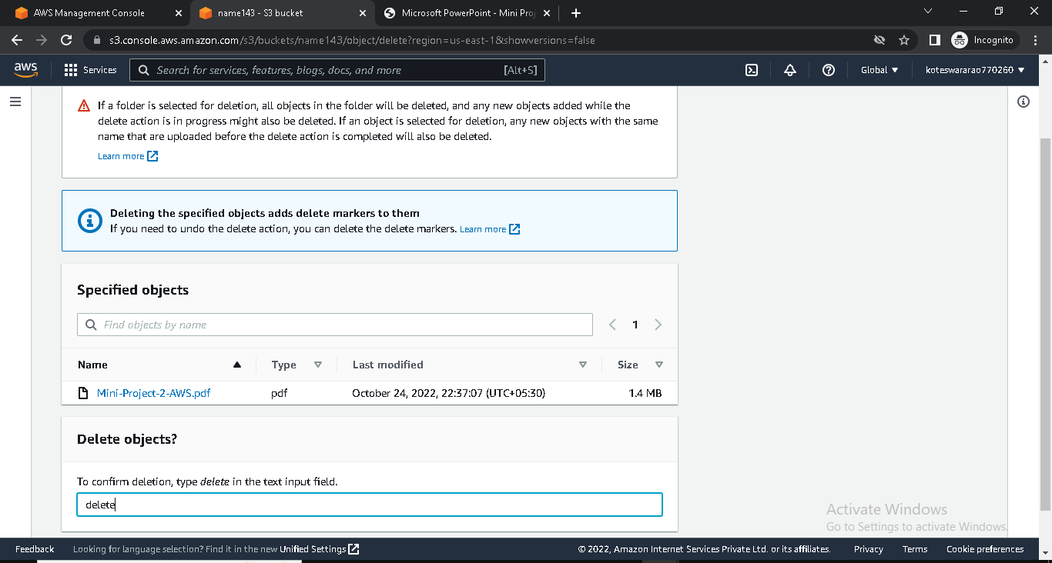

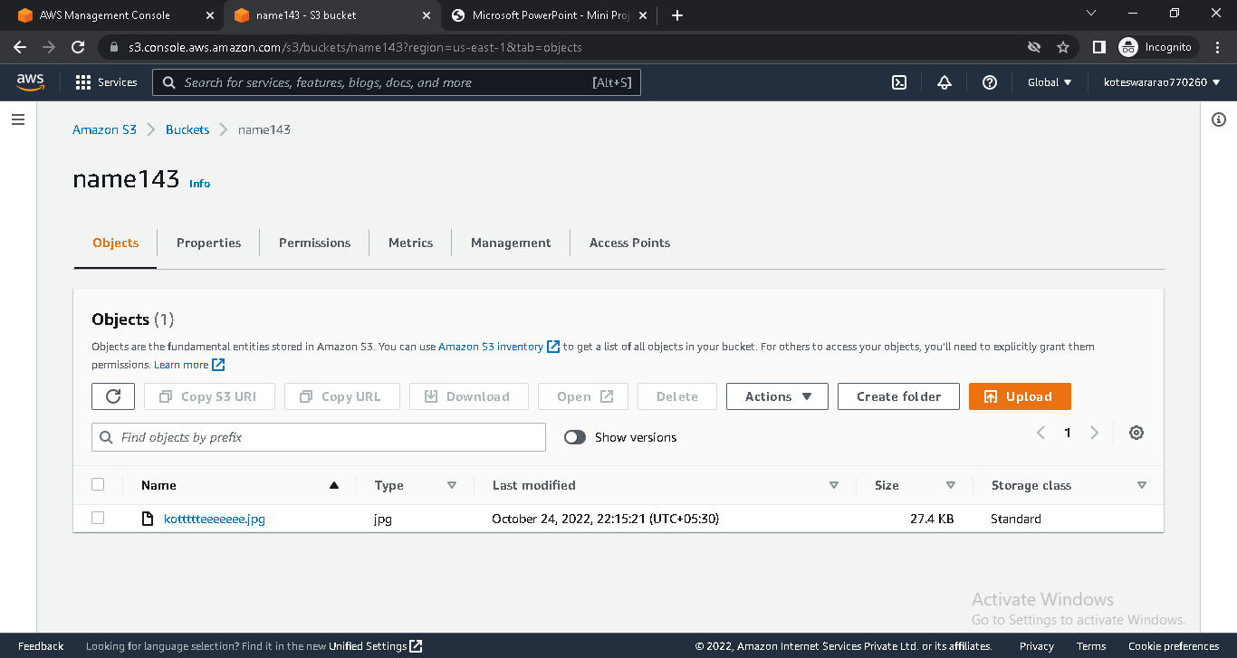

* Check files and recovery files

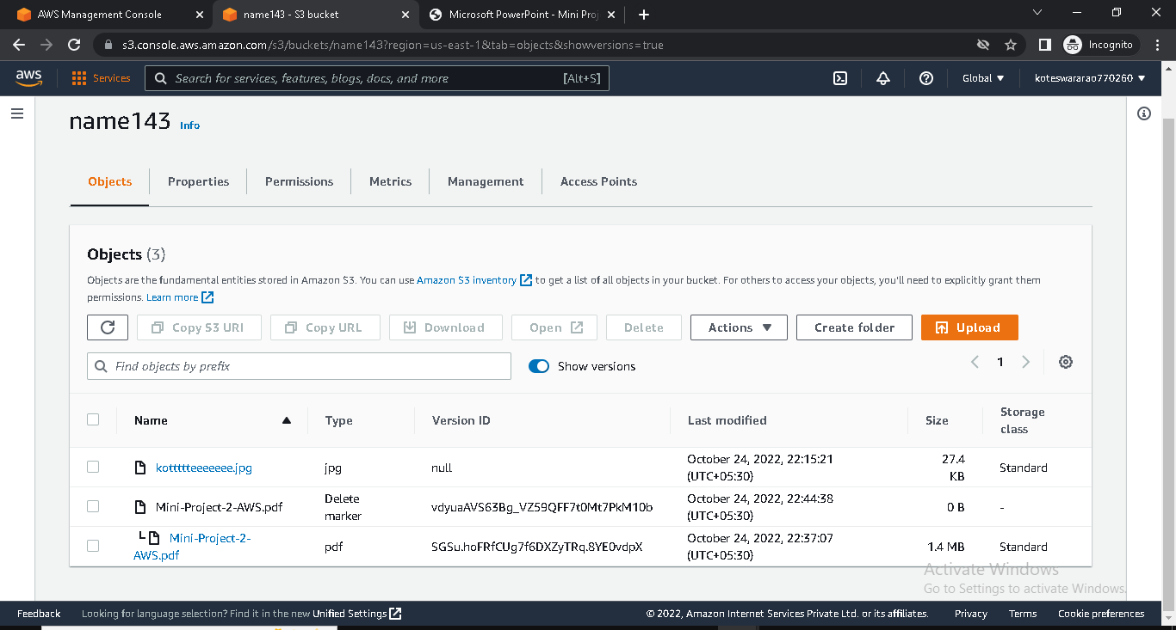

**Create EC2 instance**

* Log in into AWS console
* Go to EC2 and click on instance
* Click on launch instance
* Give name and select ubuntu AMI

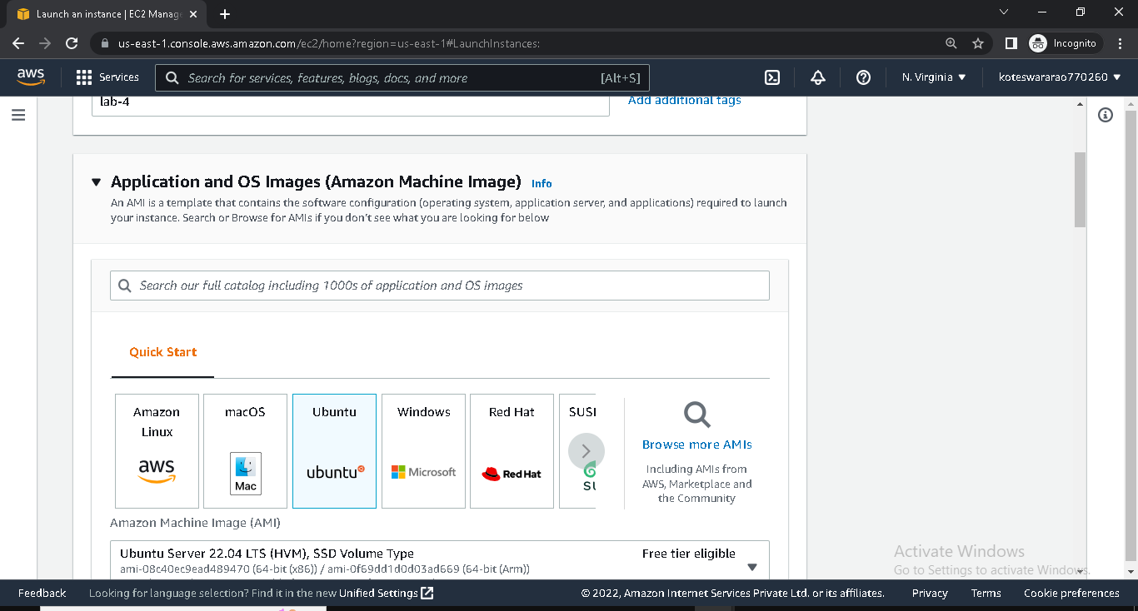

* Give t2.micro
* Select key pair

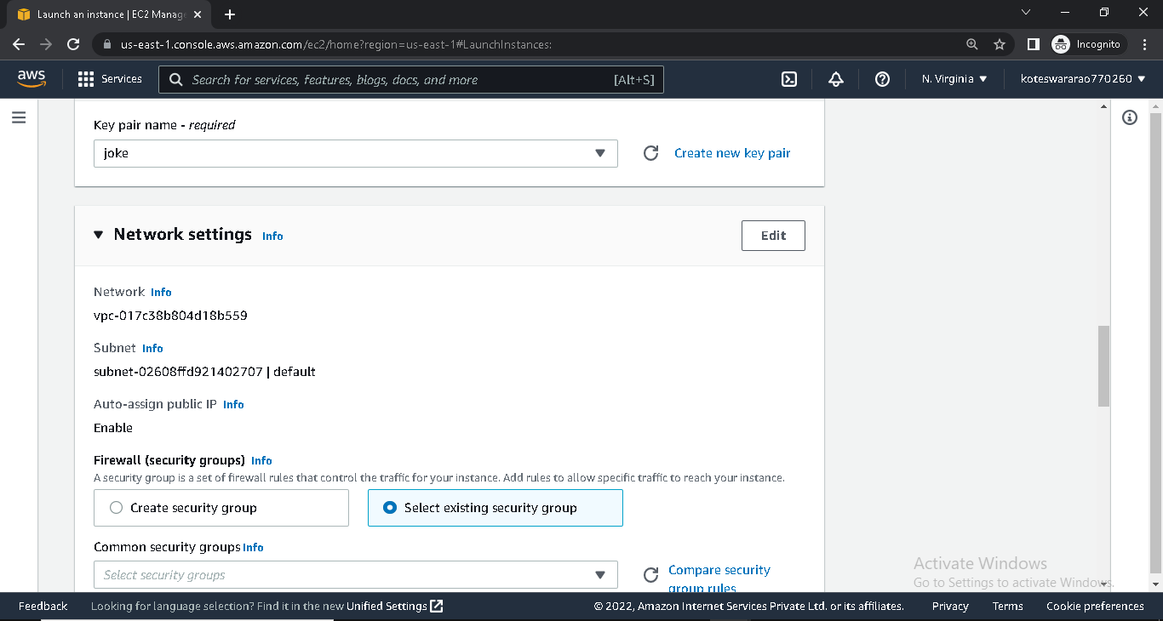

* Choose security group

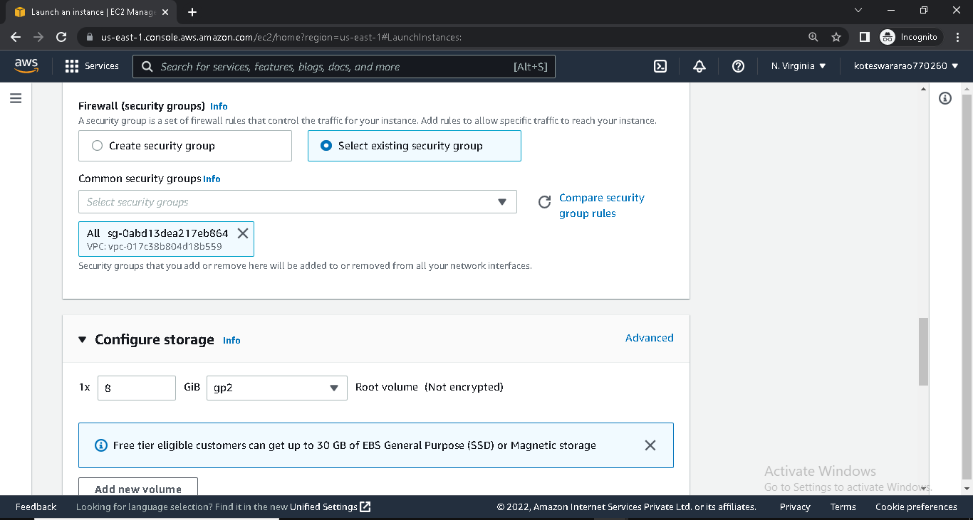

* Launch instance

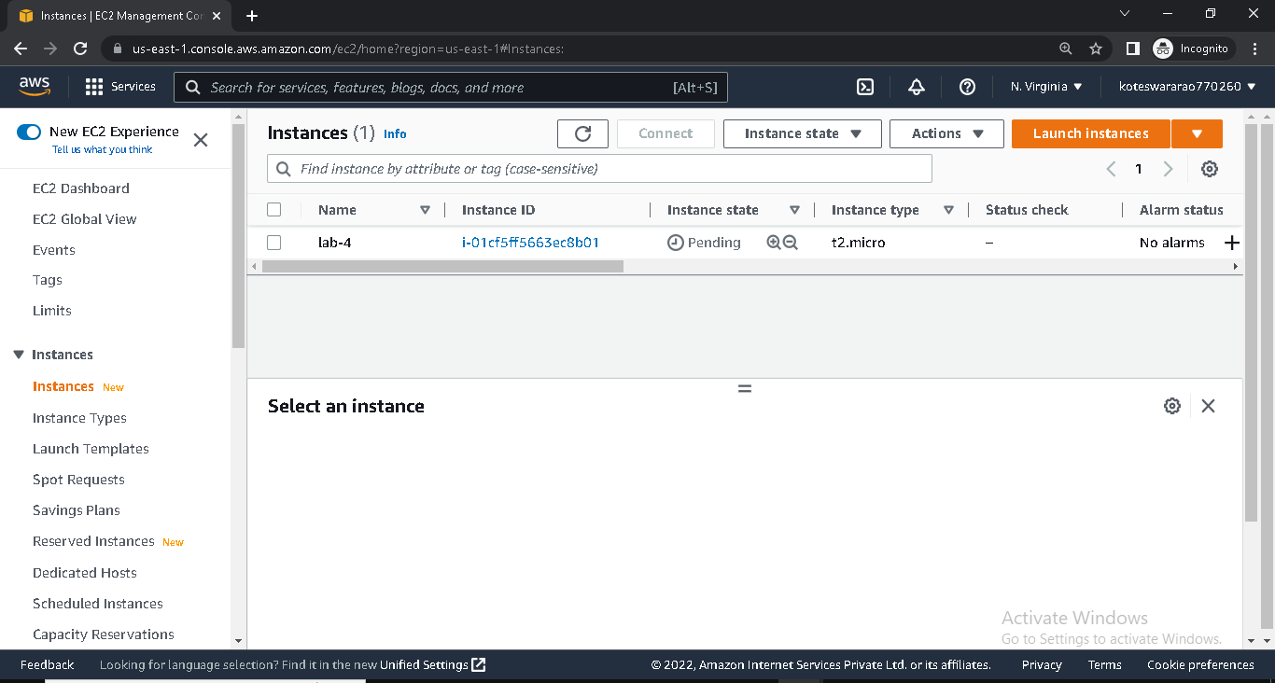

* Connect instance with git bash /putty

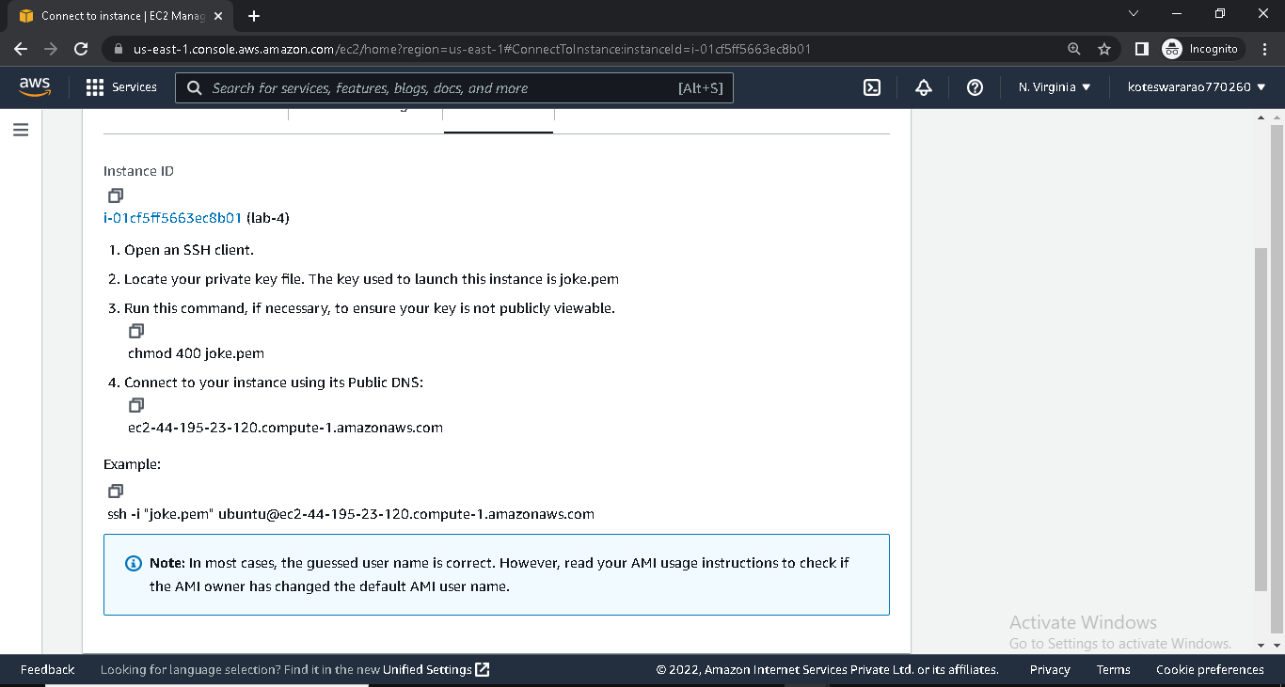

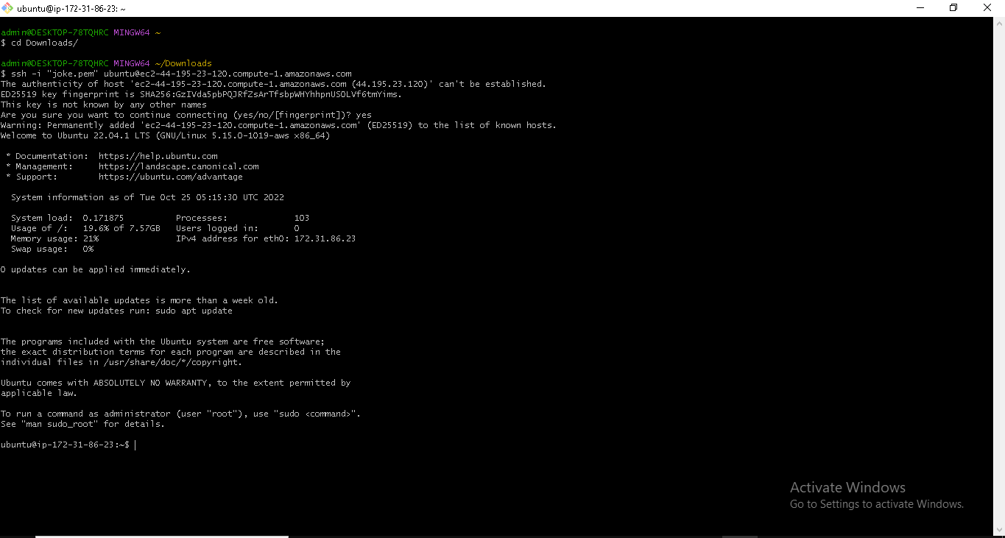

**Create New Security Group**

* Log in into AWS console
* Go to security group
* Create security group with name mynewSG

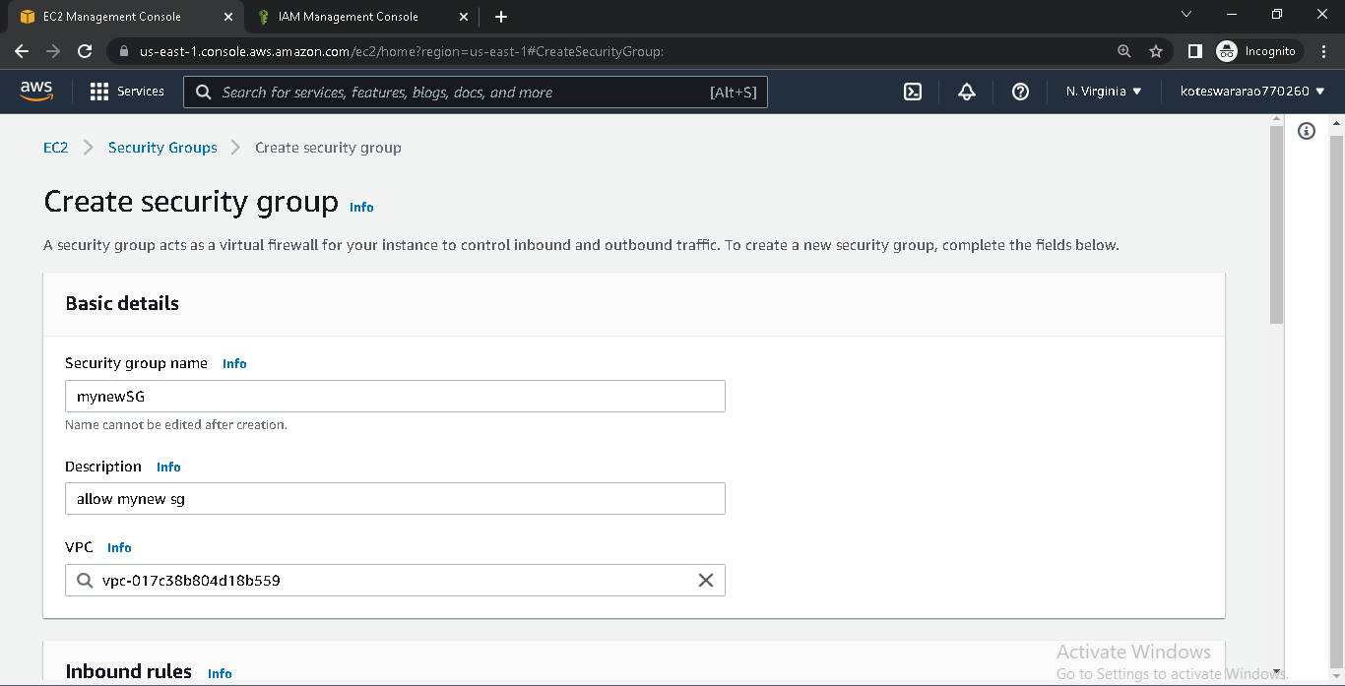

* Give the inbound rules(SSH-22,HTTP-80)

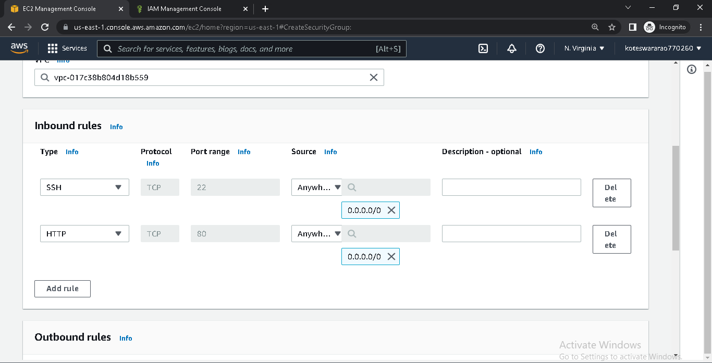

* Create EC2 attach with new security group(created one)

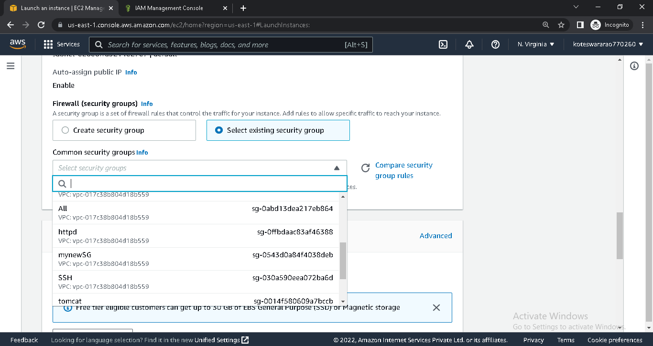

**VOLUMES**

* Login into AWS console
* Go to EC2 and Launch instance
* When launch instance add storage 5GiB and launch instance

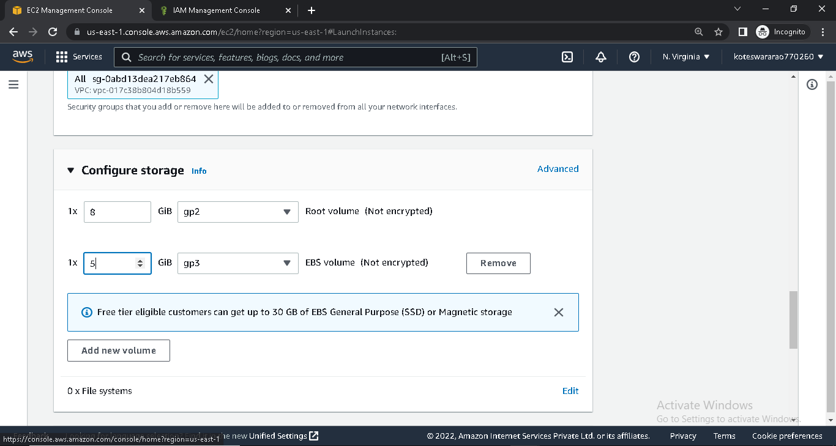

* Connect the instance in terminal
* Type lsblk command

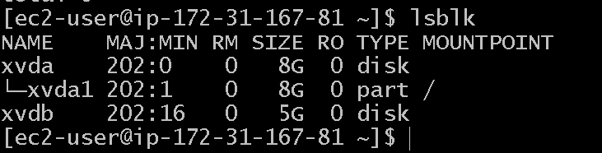

* In terminal
  + - First format the volume by using (sudo mkfs –t ext4 /dev/xvdb)
    - Create a directory (mkdir <name>)
    - Cd <directory>
* Download test file from browser

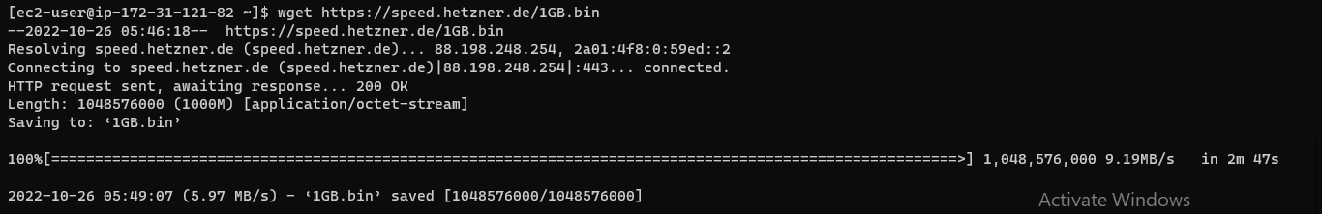

* Type command df –h(show the storage)

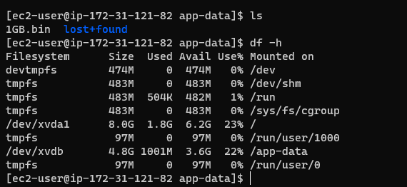

* Go to volumes and select required volume
* Go to actions and click on modify volume
* Modify and save it

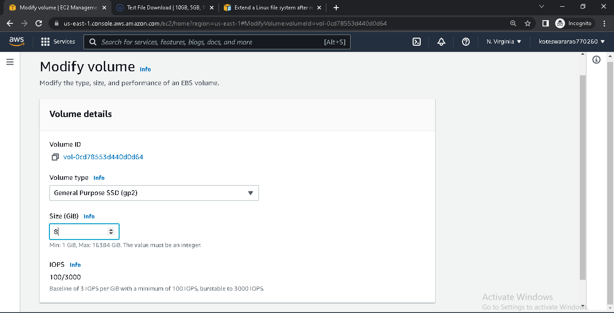

* Go to snapshots
* Create a snapshot for required volume and save it

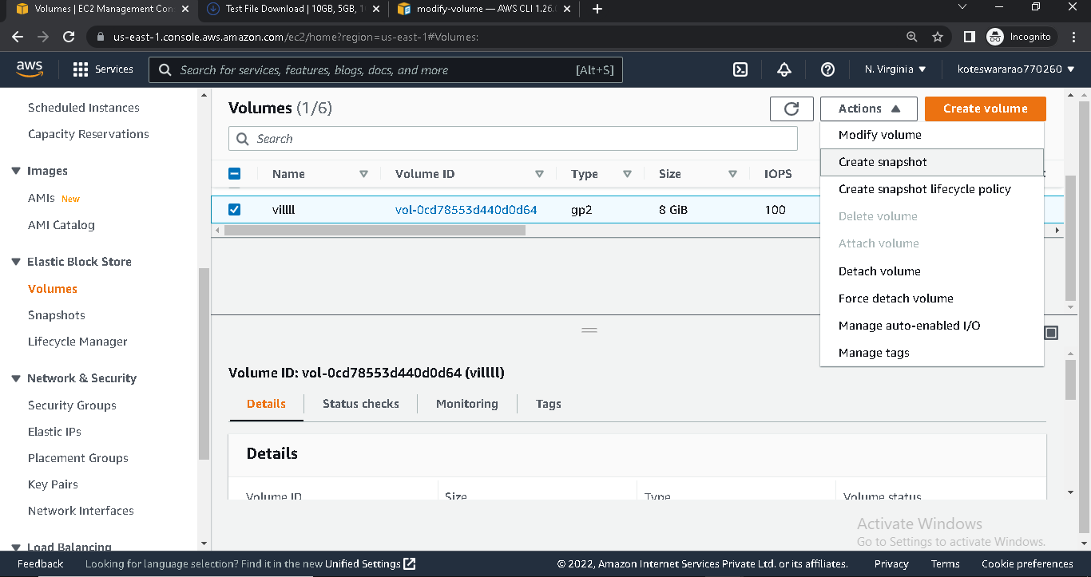

* Delete volume which one created snapshots
* Create a volume for snapshot

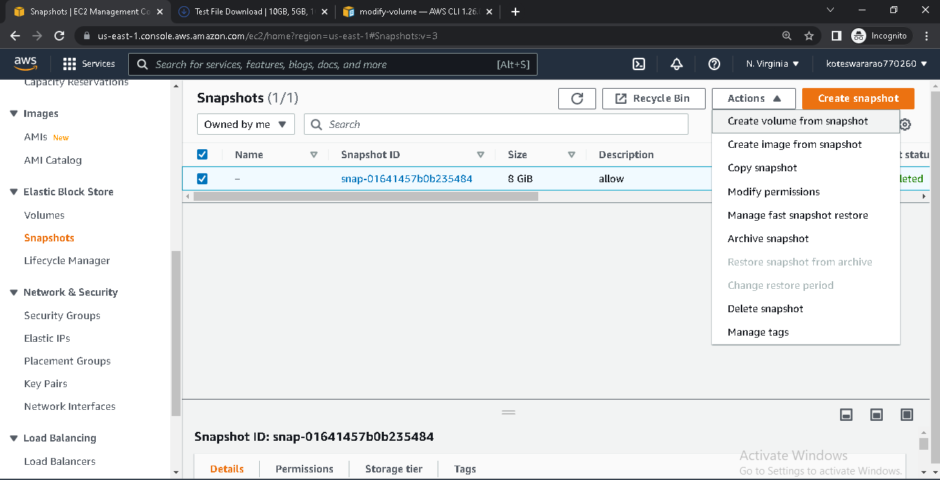

* Attach volume which is created from snapshot to EC2 instance

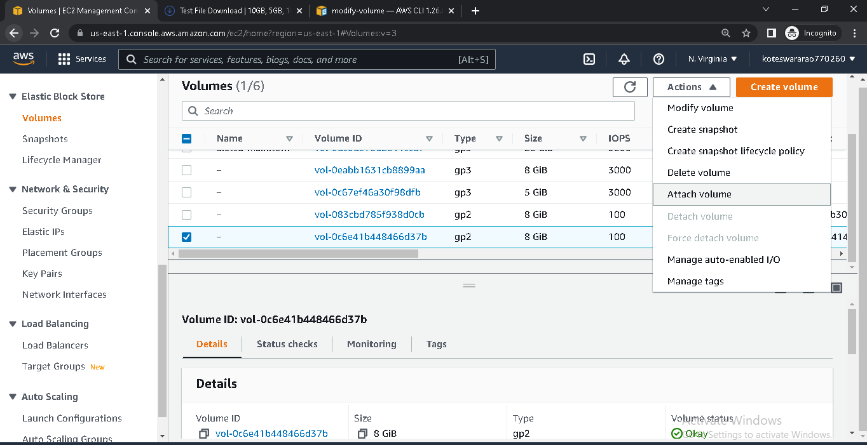

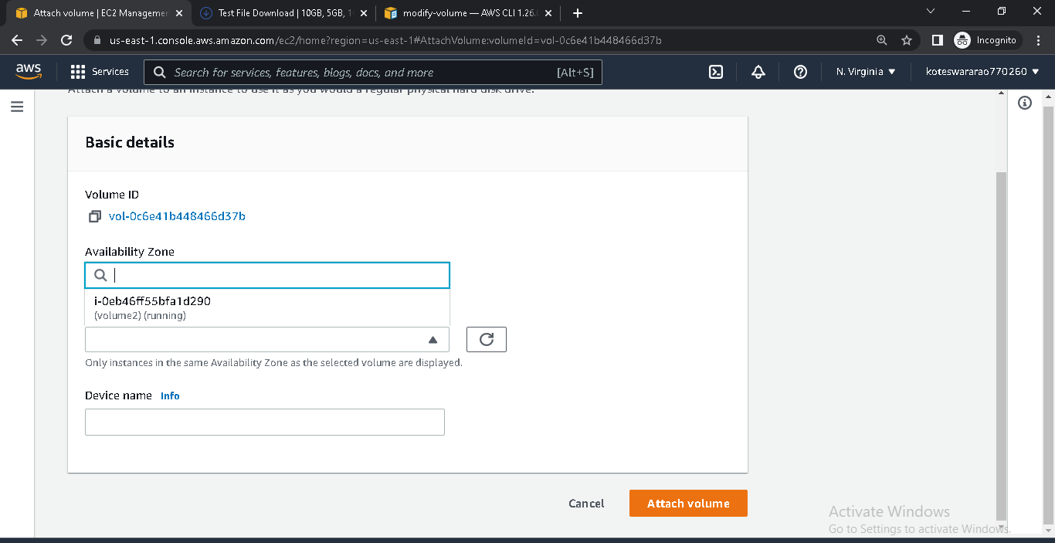

**AMAZON MACHINE IMAGE**

* Login into AWS console
* Go to EC2 and launch instance with some specifications

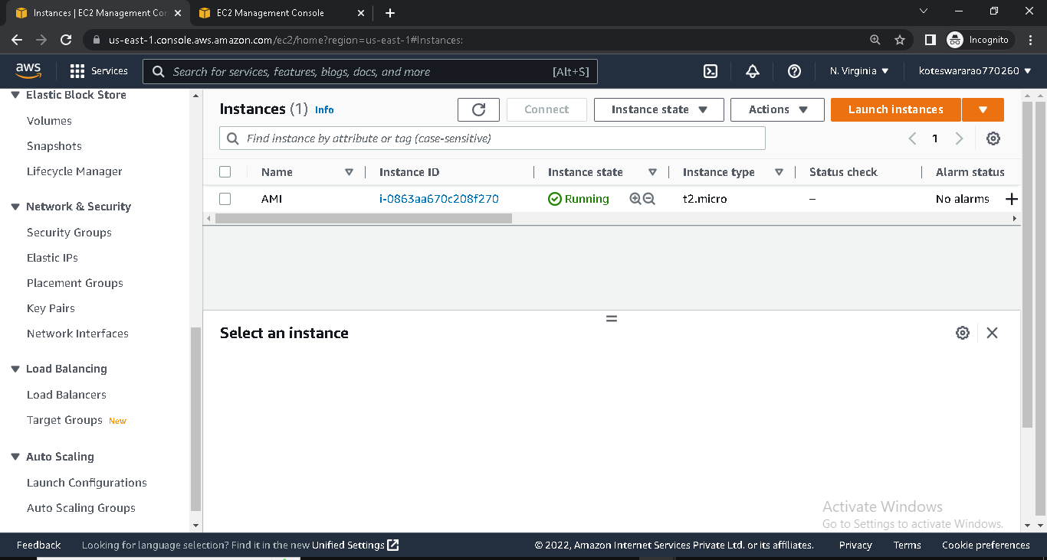

* Select running instance and go to actions
* Click on image and template
* Click on create image

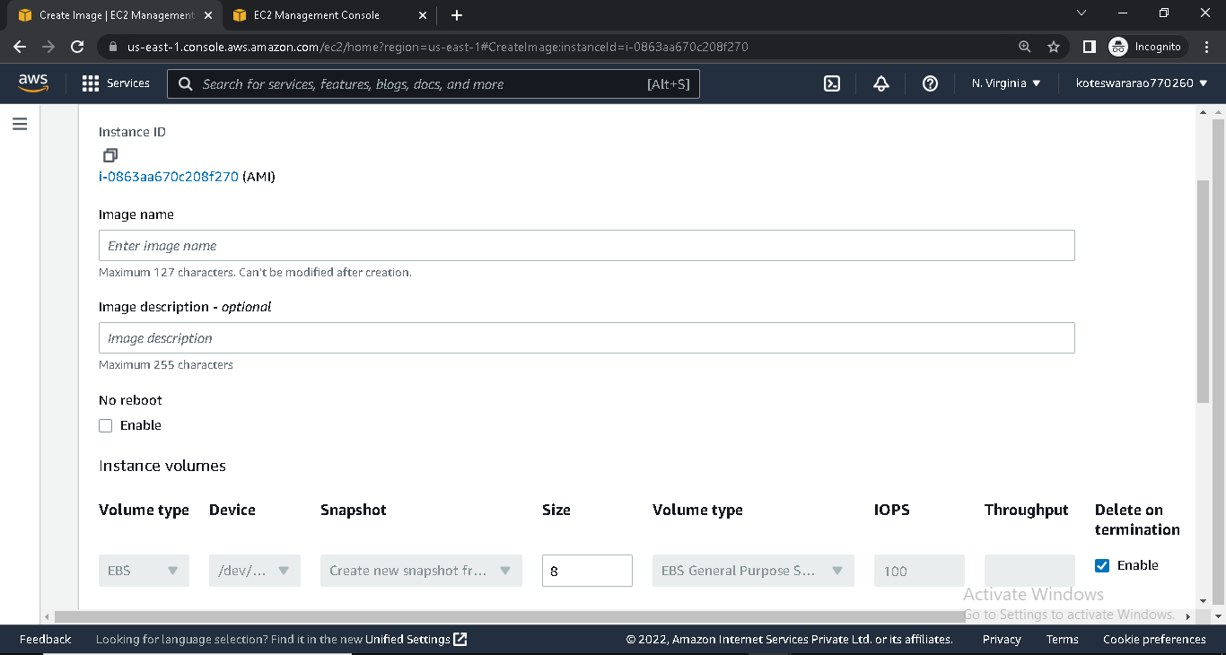

* Create the AMI
* It will show in my AMI (launch instance)

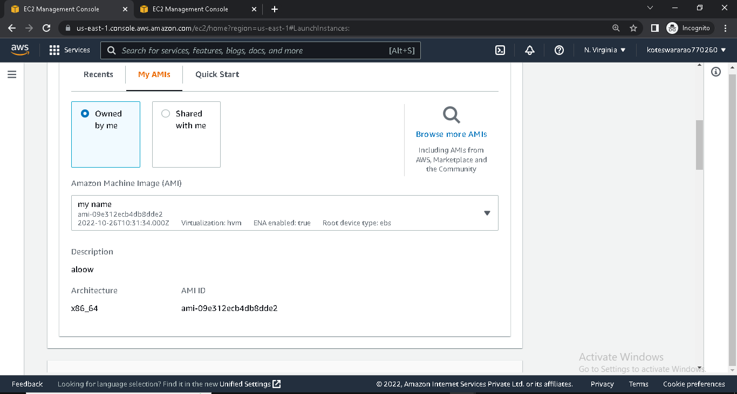

**LOAD BALANCER**

* Launch instance with Nginx port and ecomm application in user data
* Launch another instance with httpd server port and food application in user data in another availability zone
* Check these both instances



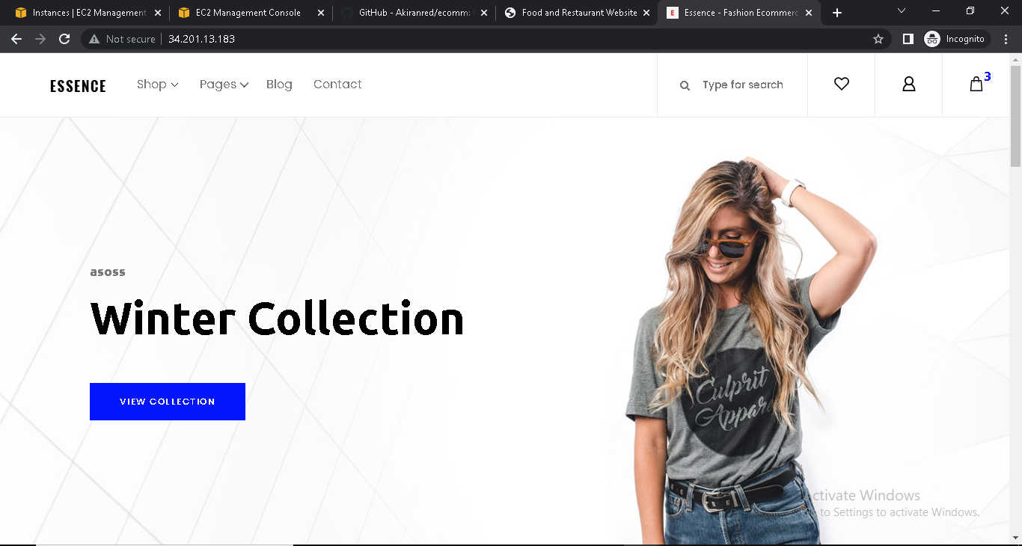

* Go to Load Balancer
* Create a Load balancer

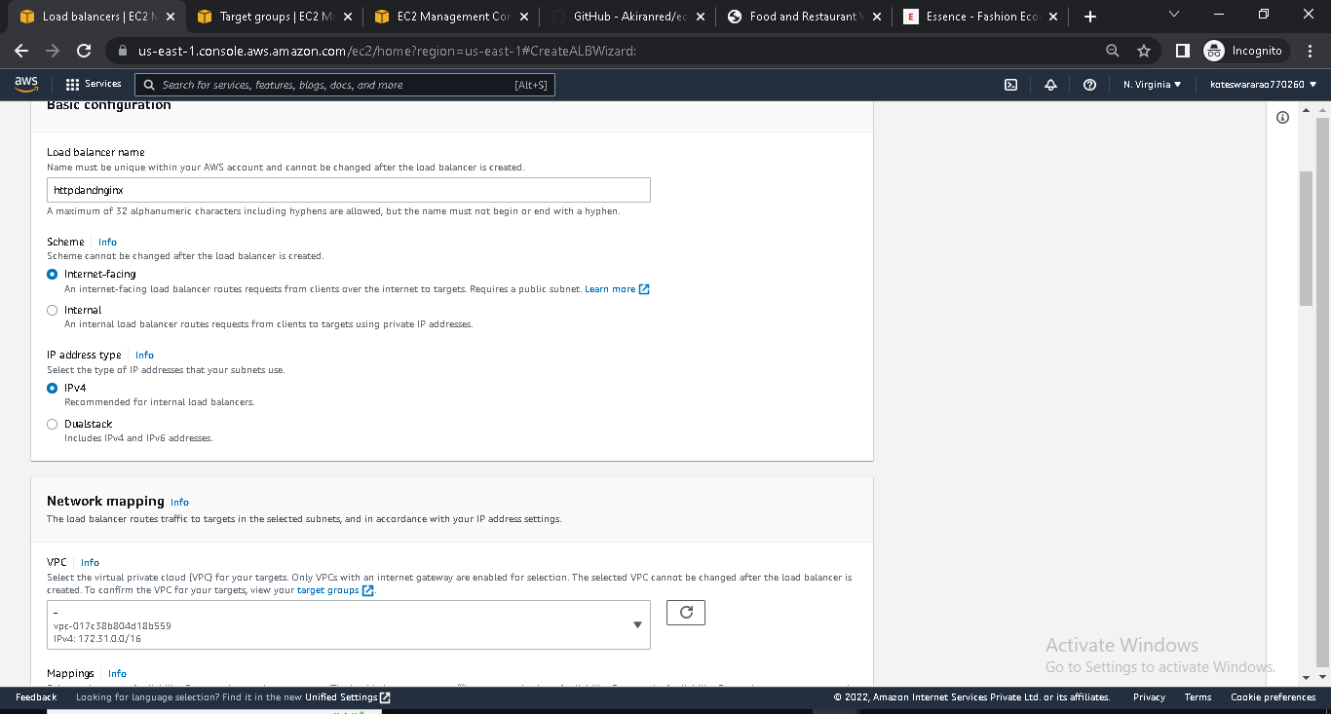

* In, Load Balancer we create Target group

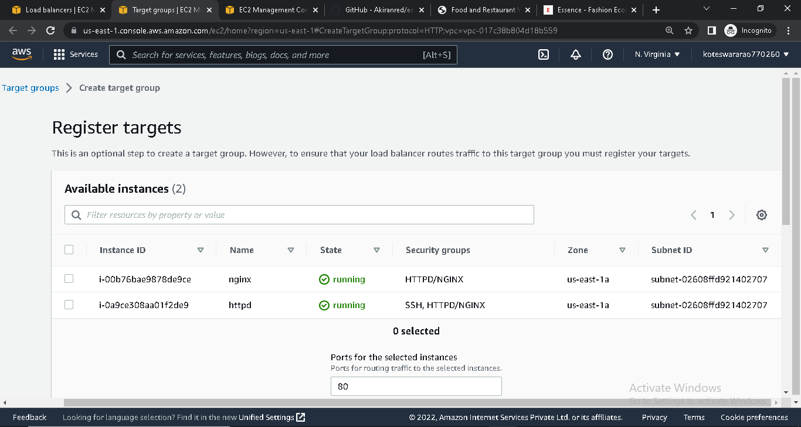

* In target group we give heath checks
* Include the instances
* Create target group

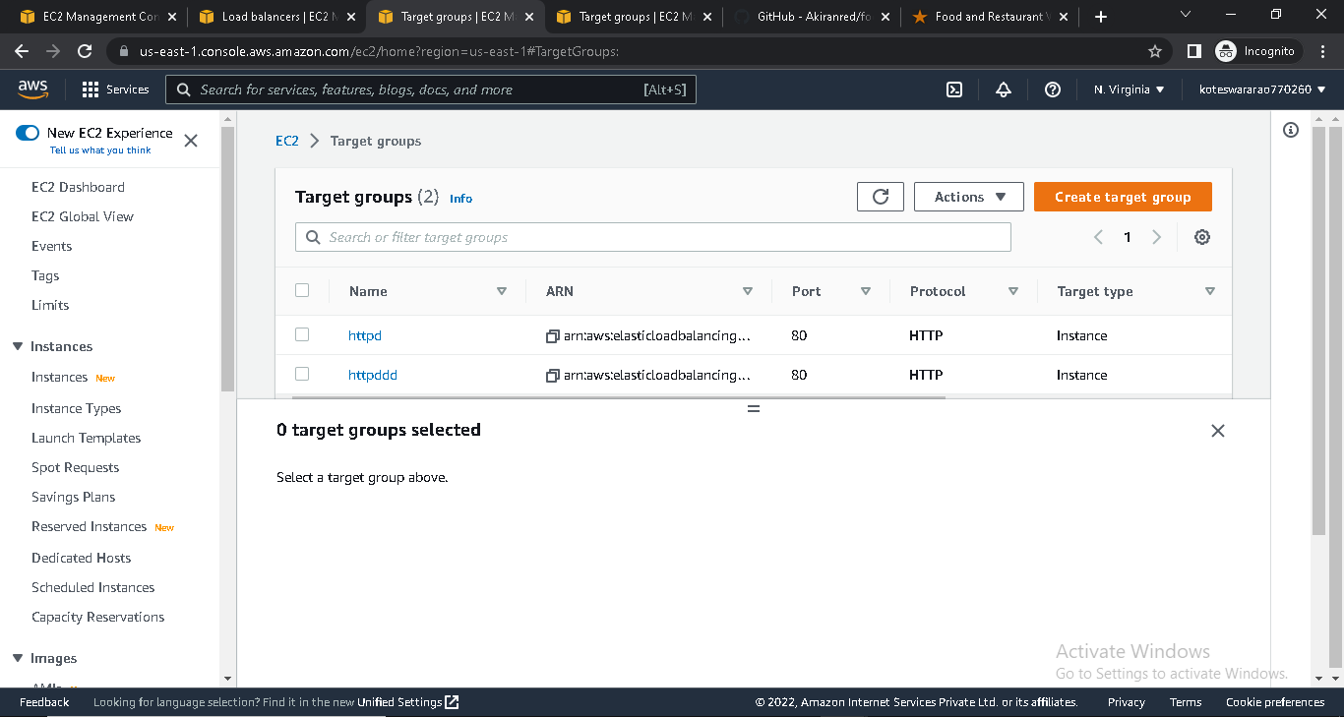

* In Load Balancer select the target group

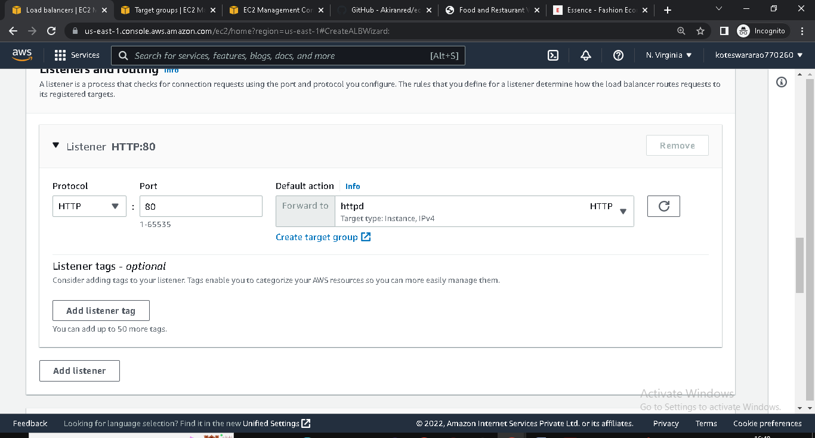

* Create Load Balancer

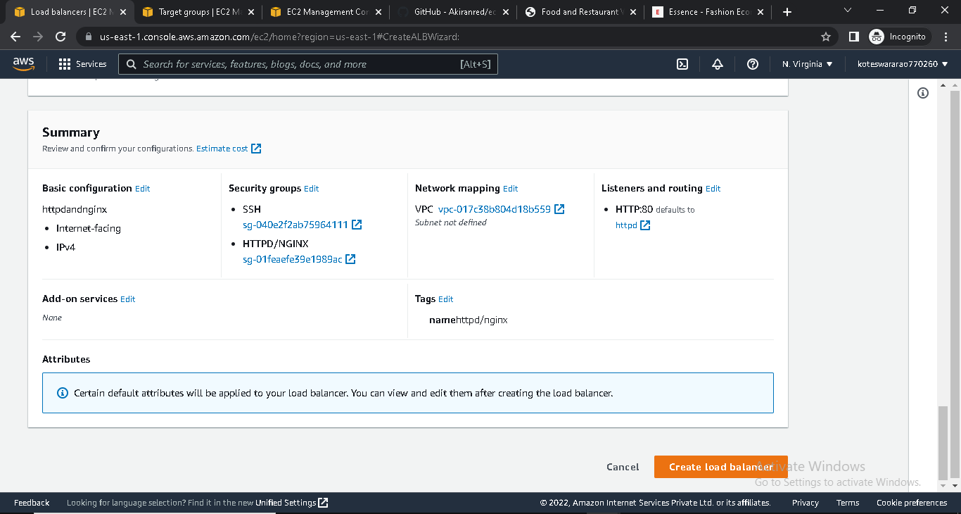

* Copy the DNS address

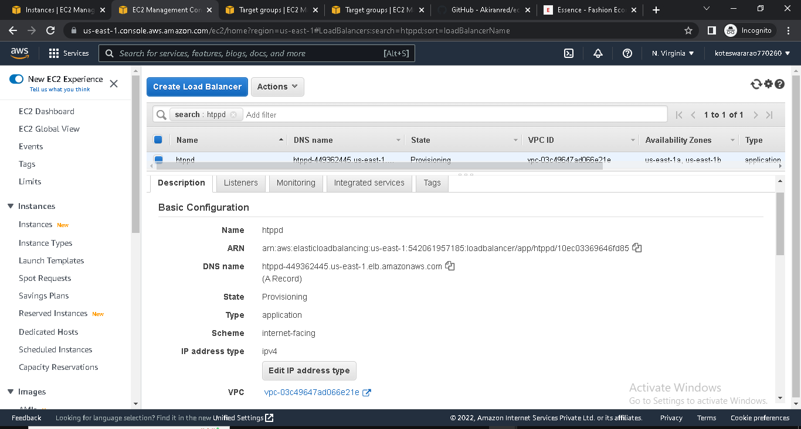

* Paste it in browser and it will show food/ecomm application(alternatively)



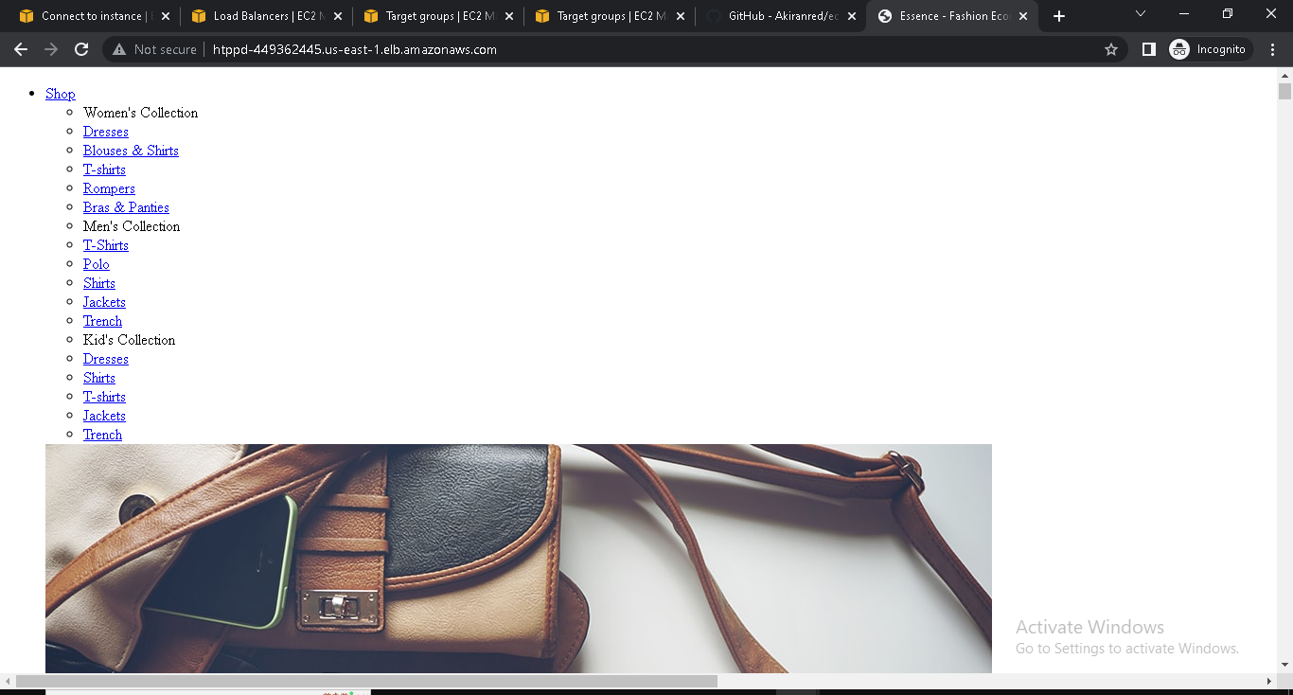

**LAUNCH CONFIGURATION AND AUTO SCALING**

* Login into AWS console
* Go to EC2 and click on Auto Scaling

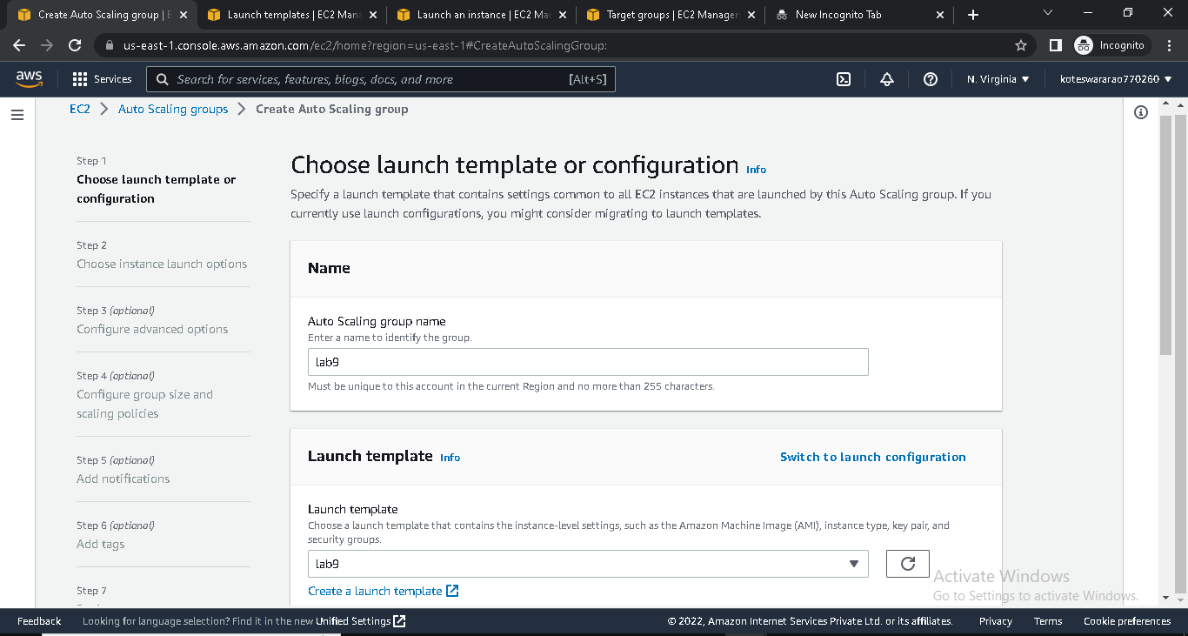

* Click on create launch template. It will go into launch template

**Launch configuration and template:-**

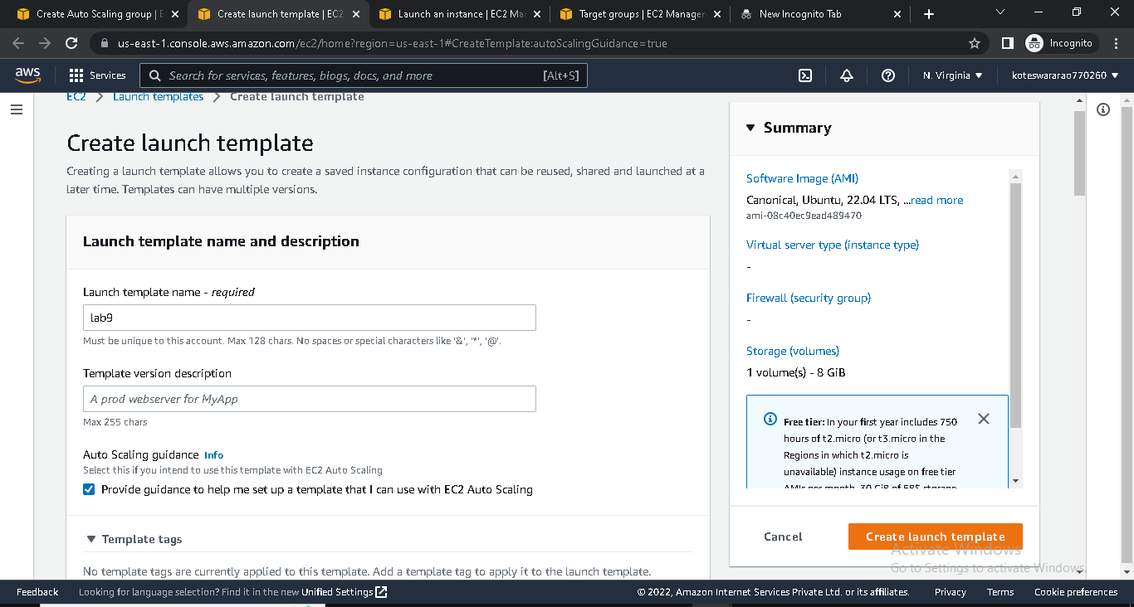

* Choose AMI Ubuntu and t2.micro

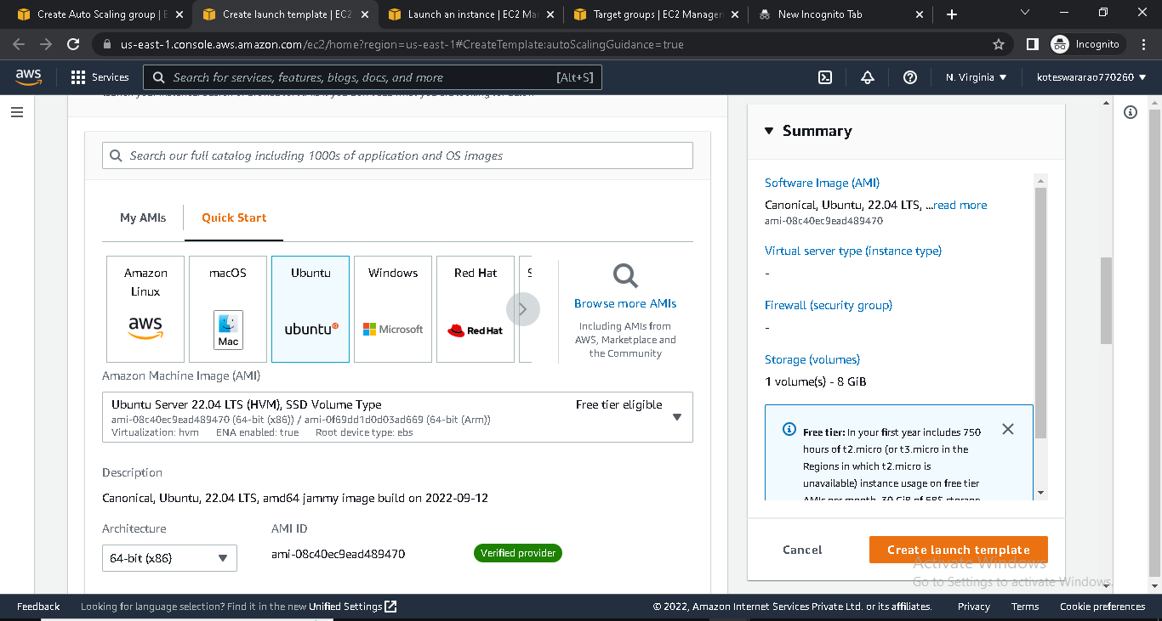

* Create Launch template
* Then , go to Auto scaling
* Choose launch template
* Choose instance launch option

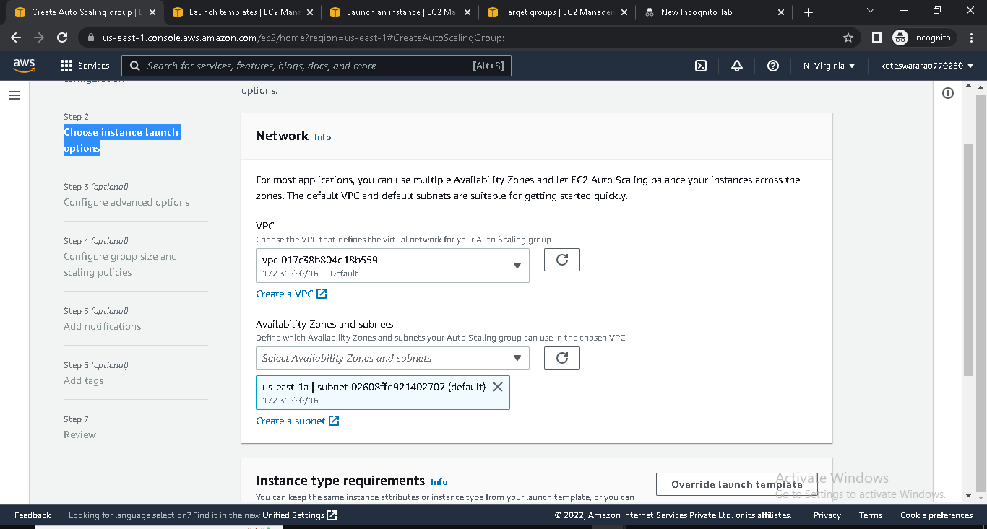

* Configure advanced options
* Configure group size and scaling policies

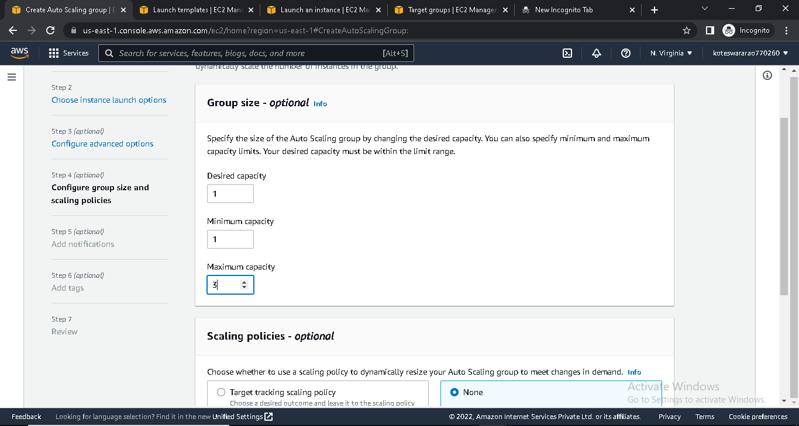

* Add notifications

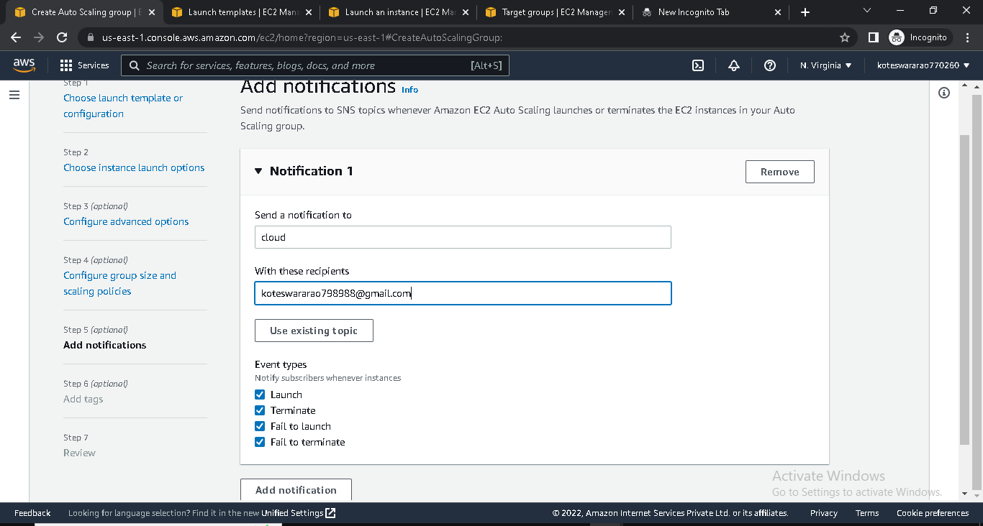

* Review and create Auto Scaling
* If we delete instance , it will create instance automatically

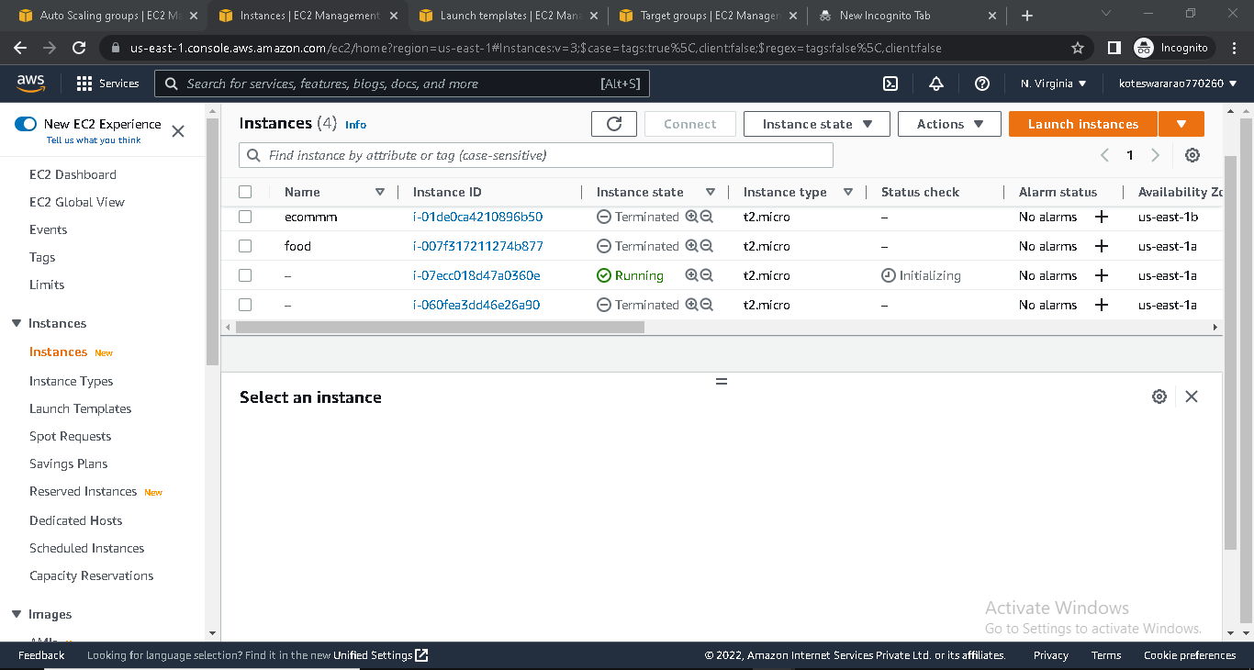

**RELATIONAL DATA BASE**

* Login into AWS console
* Go to EC2 and click on instance
* Launch instance with security group MYSQL (port-3306)

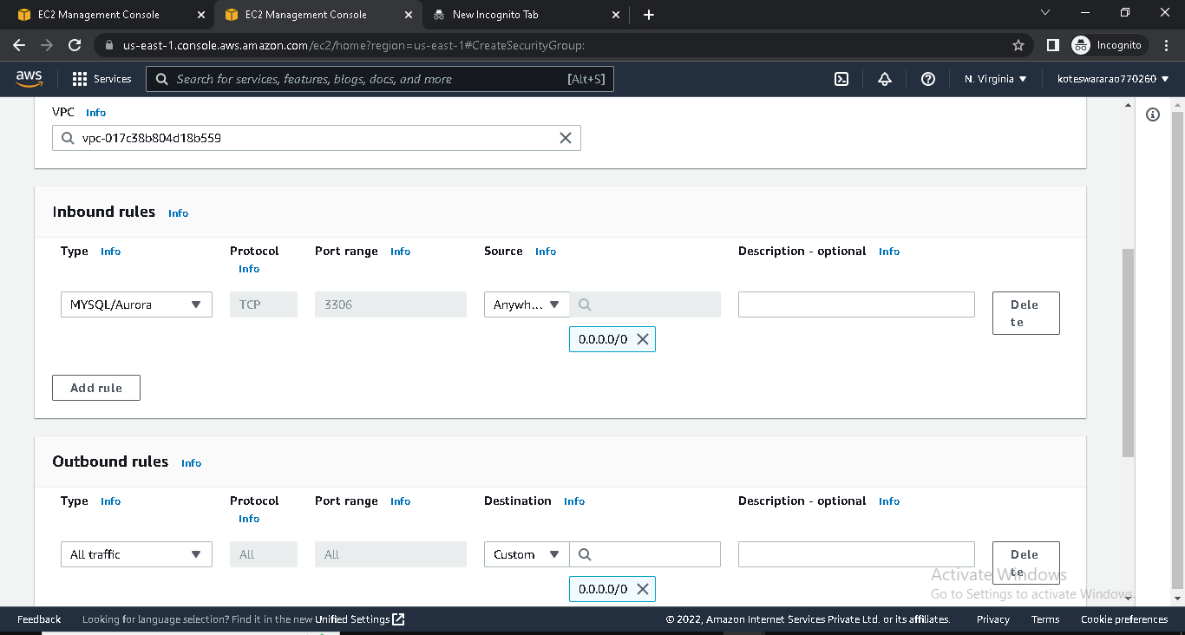

* Go to RDS

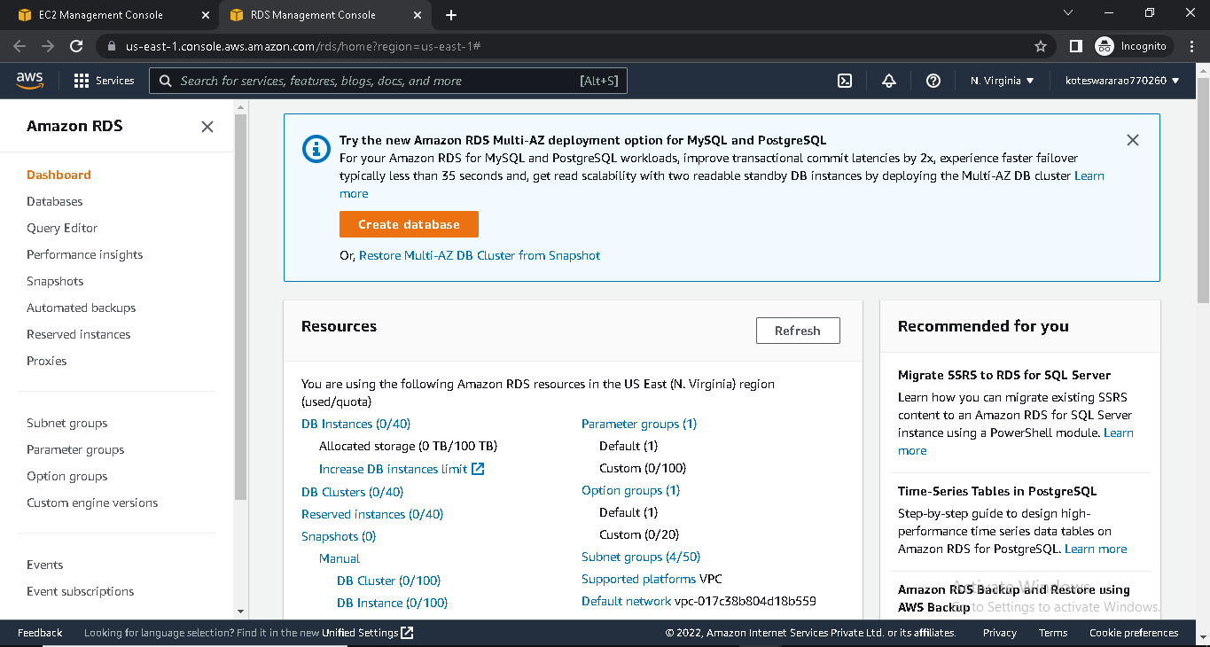

* Create database

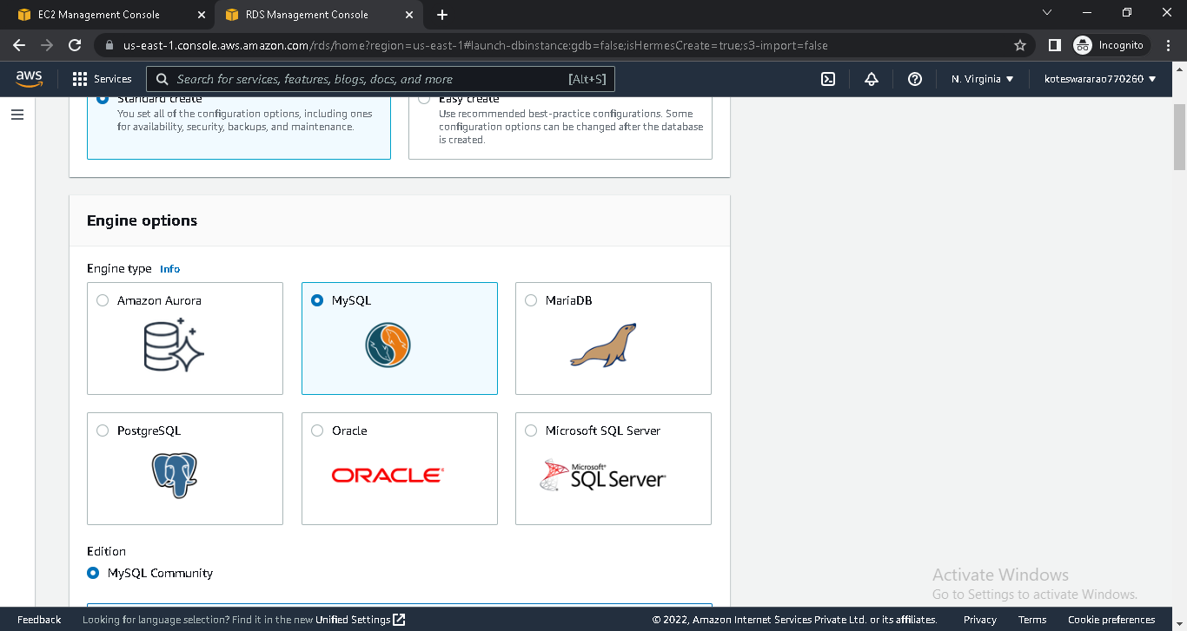

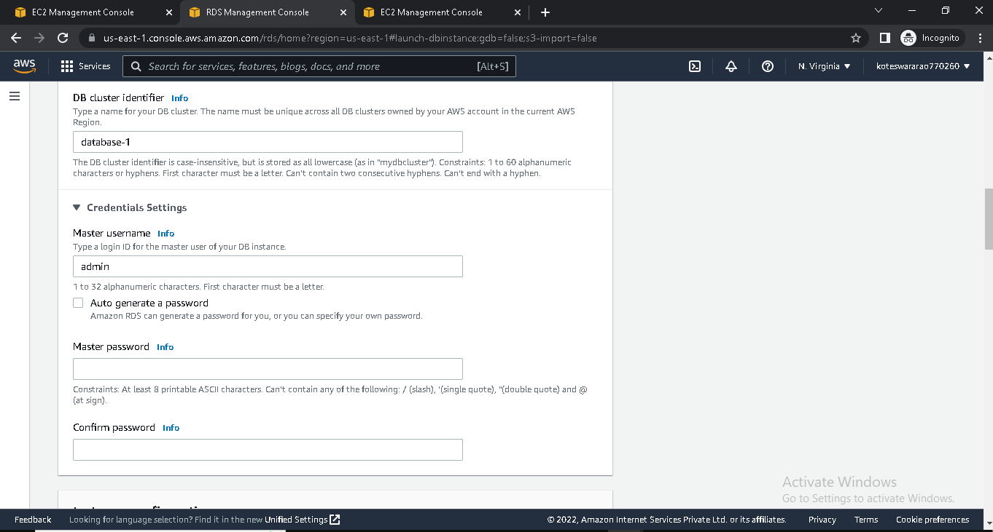

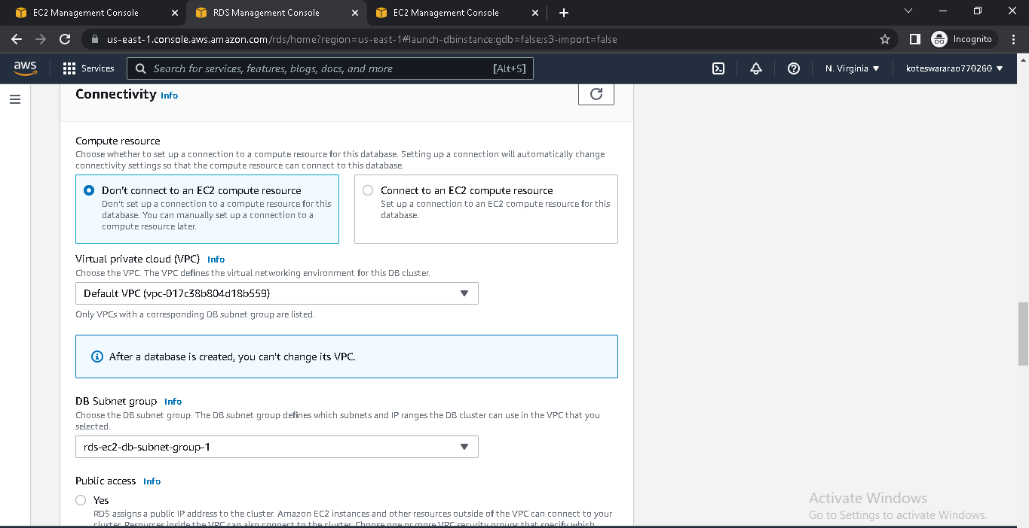

* Copy End point from created DataBase

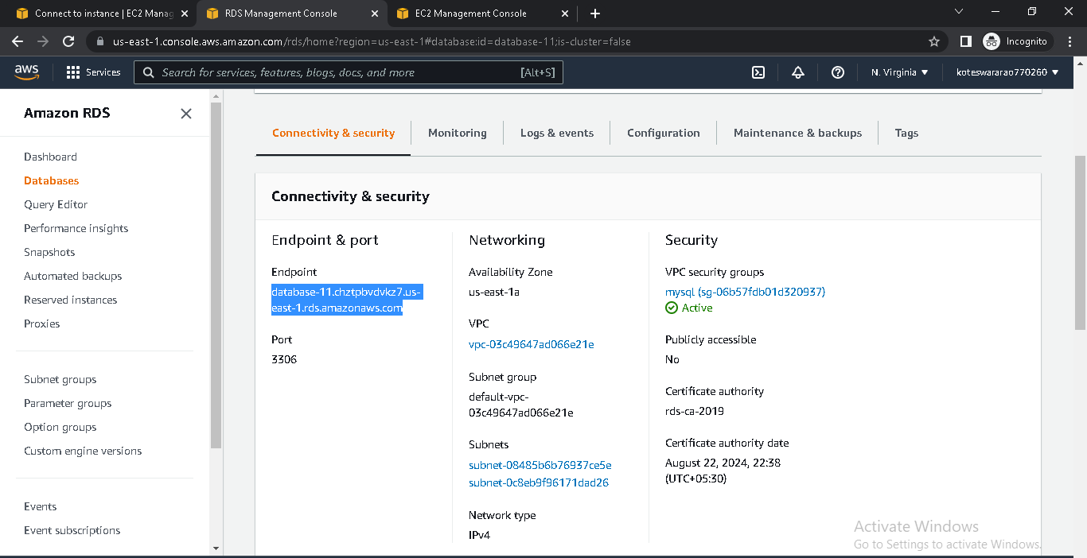

* Connect EC2 instance into terminal
* Install MYSQL by using sudo yum –y install mysql
* Connect database with instance by using

Mysql –h end point -u admin -p

* Enter password

